PRESS RELEASE
CONTACT:
Mary Beth Duehr: marybeth@duehrandassociates.com
Holly Berecz: holly@duehrandassociates.com
Duehr & Associates, LLC
1902 Wright Pl, Ste 200
Carlsbad, CA 92008
(760) 918-5622
Richelieu Debuts Smart, Stylish, and Accessible Innovations at WMS 2025
Redefining the future of design, next-generation concepts fuse technology, elegance, and practicality into every detail
(Montreal, Canada, November 12, 2025) Richelieu Hardware proudly presents a dynamic array of new, design-forward innovations at this year’s Woodworking Machinery and Supply Conference and Expo (WMS). Held November 12-14 at the Toronto Congress Centre, WMS is Canada’s leading marketplace for woodworking professionals, connecting top manufacturers, designers, and suppliers from across the globe. At this year’s event, Richelieu showcases a lineup of cutting-edge hardware systems, decorative panels, lighting, and smart security technologies—all designed to enhance accessibility, efficiency, and aesthetic appeal in residential and commercial spaces.

From versatile storage systems for kitchens, closets, and garages to thoughtfully engineered products for individuals with reduced mobility, Richelieu’s new products enhance comfort, efficiency, and quality of life in the home and beyond.

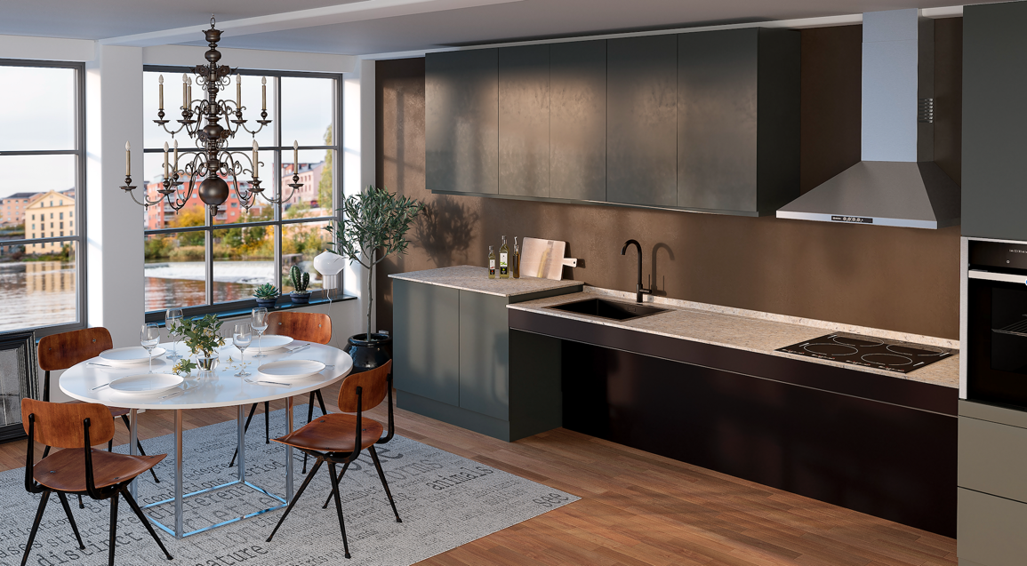
Richelieu’s Baselift 6600 height-adjustable worktop system

Advancing Accessibility and Ergonomic Design
A highlight of Richelieu’s new product lineup is the company’s collaboration with Granberg, a renowned European manufacturer of accessible kitchen and living solutions. The partnership marks an exciting step forward in Richelieu’s mission to bring inclusive, design-driven innovation to the North American market. Products such as the Butler 730 pushbutton wardrobe lift, the Baselift 6600 height-adjustable worktop system, and the Verti 840 motorized lift for upper cabinets exemplify this commitment to making modern kitchens more ergonomic, flexible, and universally accessible.
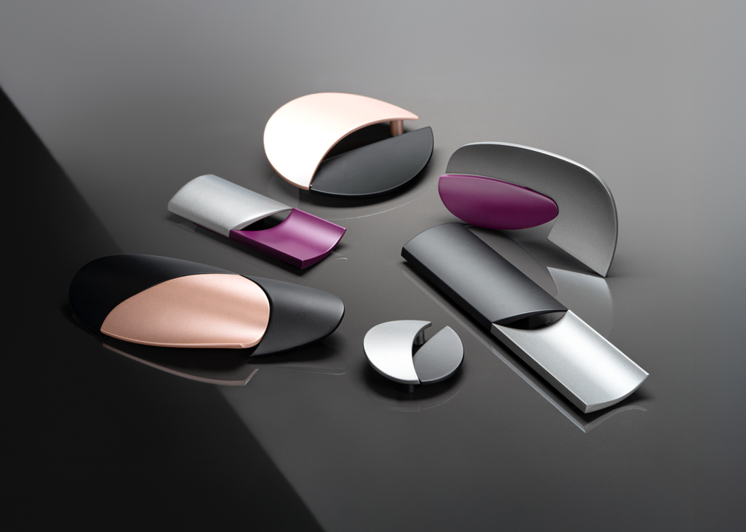
Richelieu’s ALBA Collection of sculptural decorative hardware

Decorative Hardware: Where Artistry Meets Function
Combining artistry and function, Richelieu’s new decorative hardware collections add refinement and personality to any space. The sculptural ALBA Collection, inspired by the jewelry designs of the late Italian artist Alba Lisca Polenghi, showcases graceful curves and contrasting metals. An expanded collection of refrigerator, cabinet, and furniture pulls, ranging from traditional to contemporary styles, offers woodworkers, designers, and homeowners fresh ways to express their creative vision.

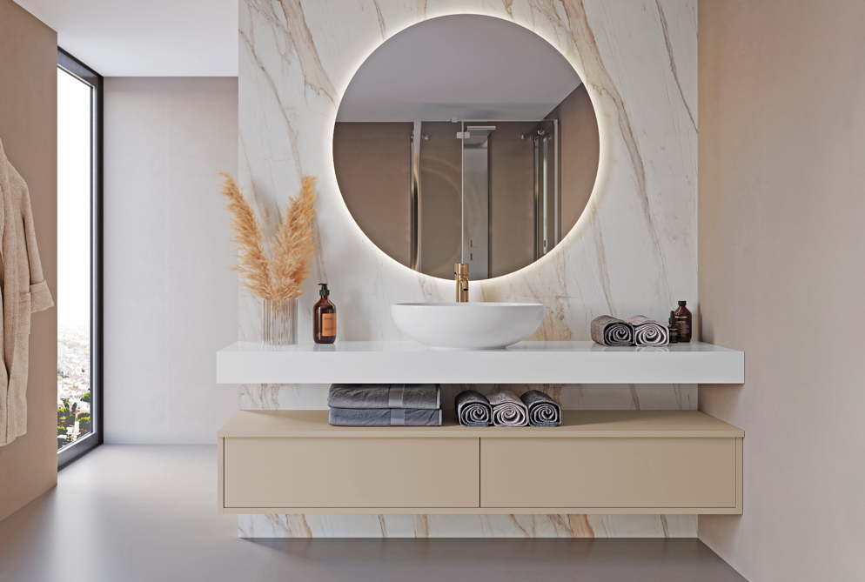
Syncron structured panels from Richelieu capture the look of natural stone

Innovative Surfacing Solutions
Richelieu’s surfacing innovations balance durability with visual impact. Syncron structured panels capture the look of natural stone, making it a great fit for modern bathrooms. The UV- and scratch-resistant panels also feature antibacterial properties for a healthier living environment. Also with antimicrobial protection, the Duo Panel – Roble Aurora 98V collection is ideal for high-traffic areas, including commercial spaces. Finished on both sides and requiring no additional finishing, the panels are UV-, scratch-, and impact-resistant. Meanwhile, the silky, ultra-matte finish of Zenit 3.0 panels conceals fingerprints for a cleaner look. The surface resists stains, delivering a sophisticated, long-lasting solution for projects of any scale.
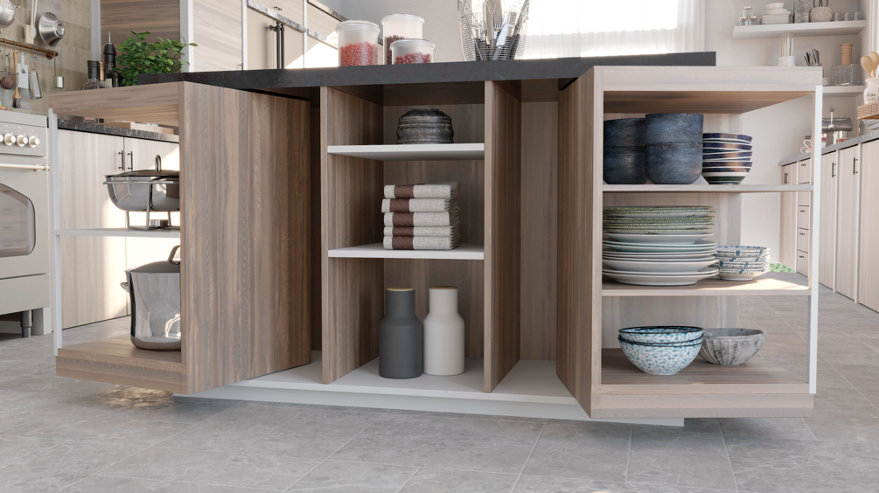
Richelieu’s ORBIX 360-degree rotating system for cabinets

Cabinet Storage Innovations
Driven by innovation and design excellence, Richelieu’s latest cabinet solutions combine advanced engineering with modern style. The high-quality, non-slip Grip Panel adds protection for drawer bottoms and sliding shelves while ORBIX, a 360-degree rotating system, allows cabinets to reveal or conceal interiors with a simple gesture.
The Turn Motion III rotating tray ensures effortless access to hard-to-reach storage and the Lilli ultra-compact flap hinge delivers minimalist, discreet precision. The LIRO pull-out system enhances accessibility and organization, simplifying storage and improving visibility. Together, these solutions support versatile, beautifully crafted cabinetry for kitchens, bathrooms, pantries, and laundry rooms.
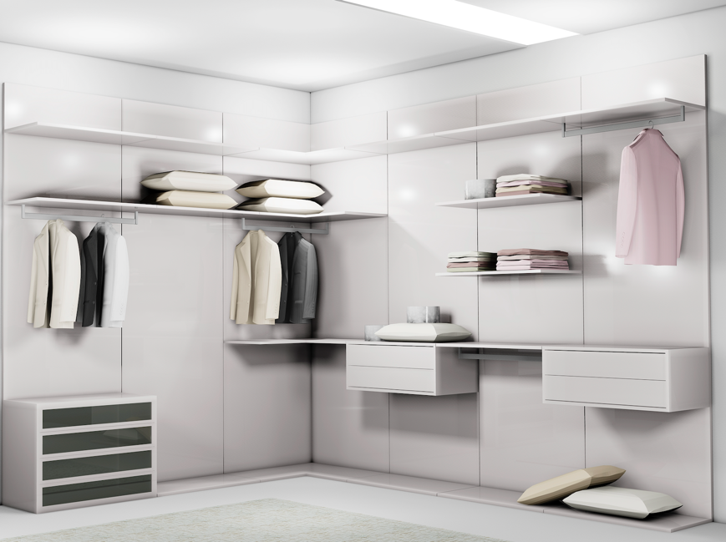
Richelieu’s VERTIKO storage system for sleek closets and living spaces

Open Storage Systems for Modern Living
As open-concept living continues to be a hallmark of contemporary design, Richelieu introduces open storage systems crafted to enhance style and function. Inspired by luxury retail design, the VERTIKO storage system features concealed aluminum profiles that create the illusion of floating elements for sleek closets and living spaces. The LOGO III modular system can be customized to fit virtually any space with floor-to-ceiling or wall-mounted configurations that support rods, shelves, and drawer units. The YOUK open shelving system features six different configurations that can be combined as desired for the ultimate flexibility.
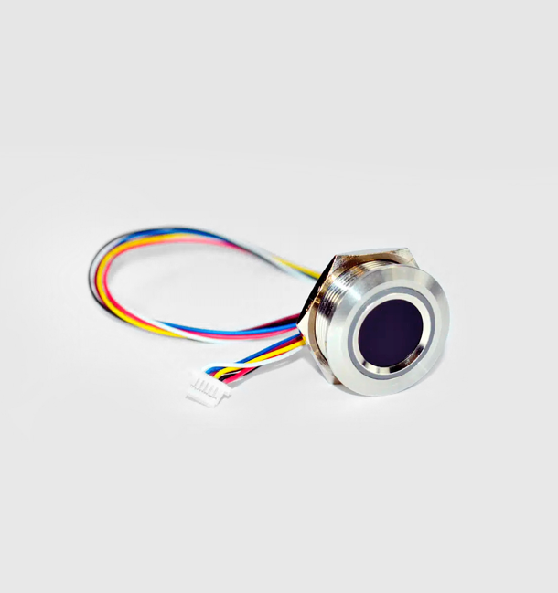
Richelieu’s Electric Fingerprint Lock for quick, secure entry

Smart and Secure Access Solutions
Richelieu addresses the need for secure, keyless access with innovative new products. The Digital Keypad Lock features a scratch-resistant, soft-touch keypad, and easy management via the LEHMANN Smart Secure App. The Electronic Fingerprint Lock provides quick, secure entry with ultrafast scanning and a sleek design. The Giro Keypad Lock combines flexible code options, LED feedback, and a durable rotating body, long-lasting battery, and emergency key for added peace of mind. These solutions deliver convenient, reliable and stylish security for modern spaces.

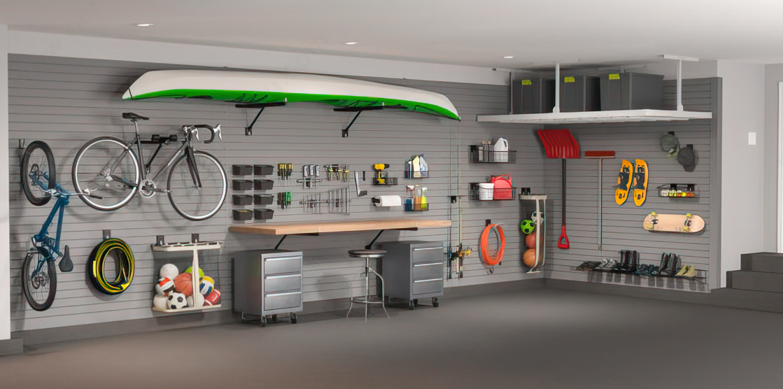
The Slatwall system from Richelieu maximizes efficiency and style in the garage

Organized and Stylish Garages
Modern garages are becoming organized, visually appealing extensions of the home. Richelieu’s customizable storage systems help maximize efficiency and style. The
Slatwall system offers panels, hooks, baskets, bike racks, and other accessories to keep spaces neat and functional, transforming the garage into an appealing space that complements the home’s overall design.

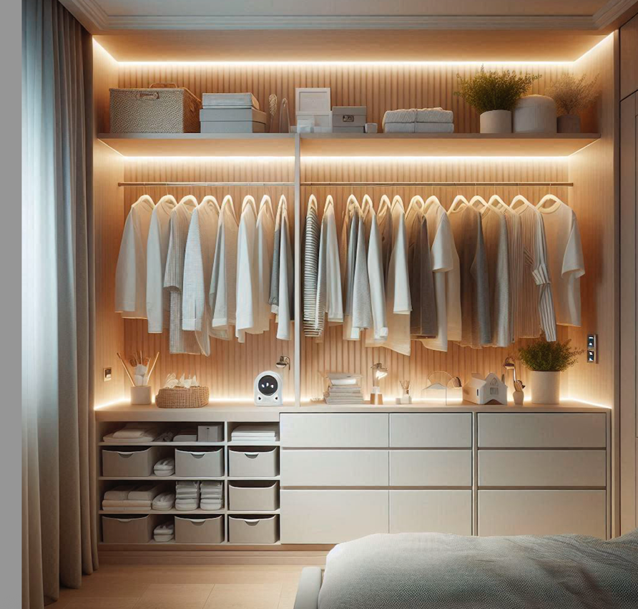
FlexyLED systems from Richelieu offer refined illumination

Lighting for Every Environment
Richelieu’s FlexyLED systems provide seamless illumination for a refined look. The FlexyLED AT6 is a flexible linear module with silicone-encapsulated technology, delivering smooth “dot-free” light in a compact profile for recessed or surface installation. The FlexyLED SEH4 fits straight, curved, or circular grooves, integrating effortlessly into cabinetry and built-ins. Both systems are easy to install with pre-wired cables and deliver clean, minimalist lighting for any space.

Richelieu continues to redefine modern living with thoughtfully designed, innovative solutions. The company’s commitment to quality, inclusivity, and forward-thinking design empowers homeowners, designers, architects, and builders to transform interiors into functional, beautiful, and enduring spaces.

About Richelieu
Richelieu is a leading North American importer, manufacturer, and distributor of specialty hardware and complementary products. An agent of change in a dynamic and creative industry, the company offers a broad mix of high-end, quality solutions for kitchens, bathrooms, closets, and cabinet storage. Richelieu’s products, sourced from worldwide manufacturers, serve a wide range of sectors including residential and commercial woodworking, furniture manufacturing, door, window, and hardware retailers, and renovation superstores.

###

