PRESS RELEASE
CONTACT:
Mary Beth Duehr: marybeth@duehrandassociates.com
Holly Berecz: holly@duehrandassociates.com
Duehr & Associates, LLC
1902 Wright Pl, Ste 200
Carlsbad, CA 92008
(760) 918-5622
Richelieu to Debut Practical, Stylish and Accessible Innovations at KBIS 2026
Design-forward hardware, storage, lighting and surfacing solutions redefine versatility for modern living
(Montreal, Canada, February 10, 2026) Richelieu Hardware will unveil a dynamic lineup of design-forward innovations at the 2026 Kitchen & Bath Industry Show (KBIS), taking place February 17-19 in Orlando, Fla. As North America’s premier kitchen and bath trade show, KBIS brings together the industry’s leading design professionals and manufacturers. At the show, Richelieu will showcase cutting-edge hardware systems, decorative panels and organizational solutions designed to shape the future of kitchen and bath design.

Versatility is a key focus for Richelieu’s newest product introductions. From a kitchen cabinet that rotates 360-degrees—allowing contents to be concealed or displayed on demand—to a collapsible, compact table that effortlessly creates space for work, dining or entertaining, each innovation is thoughtfully engineered to adapt to today’s modern lifestyles. Richelieu’s new offerings deliver versatile storage solutions for the entire home alongside purpose-driven designs for individuals with reduced mobility, elevating comfort, efficiency, and quality of life.
Accessibility Innovation:
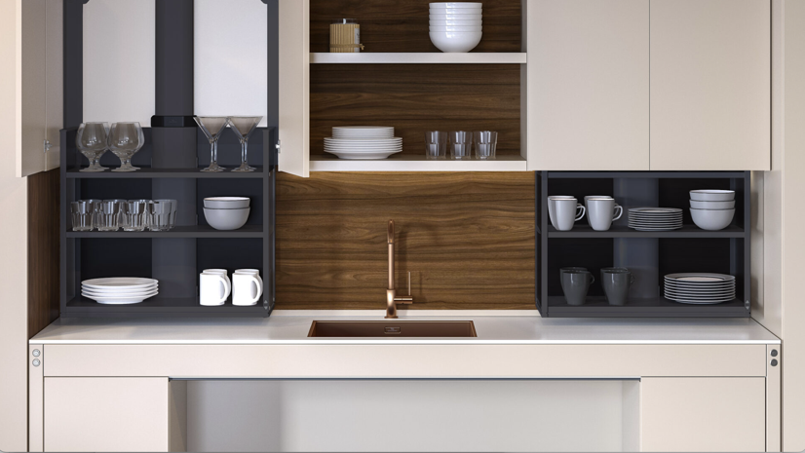
Caption: Richelieu’s VERTI 840 motorized lift

Richelieu places accessibility for all at the heart of everything it designs. Through a new collaboration with Granberg, a renowned European manufacturer of accessible kitchen and living solutions, the company now offers the VERTI 840 motorized lift for upper cabinets. A finalist for the prestigious “Best of KBIS” awards in the “Wellness Trailblazer” category, VERTI 840 helps users avoid stretching and straining. With a simple touch, the smart electric height-adjustable lift system smoothly, silently and safely brings cabinet shelves down to countertop level. Designed to integrate seamlessly into virtually any kitchen, VERTI 840 exemplifies Richelieu’s commitment to creating modern kitchens that are more ergonomic, flexible and universally accessible.

Decorative Hardware Collections:
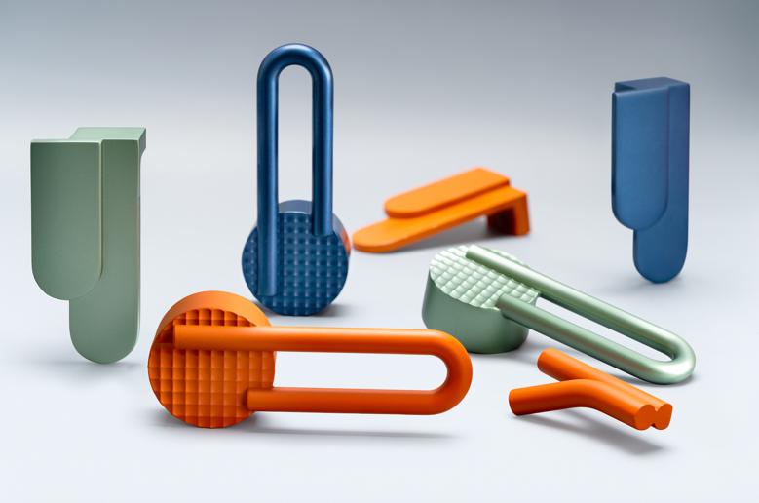
Caption: Richelieu’s Atipica hardware, designed by Gianmarco Codato and Luciano Trevisiol

Designed by Gianmarco Codato and Luciano Trevisiol, the Atipica designer hardware collection lets designers add character and identity to any project. Derived from the Italian word for “atypical,” Atipica is defined by eccentric geometric shapes and textures. The collection is a finalist for the “Best of KBIS” awards in the “Style Statement: Kitchen” category.

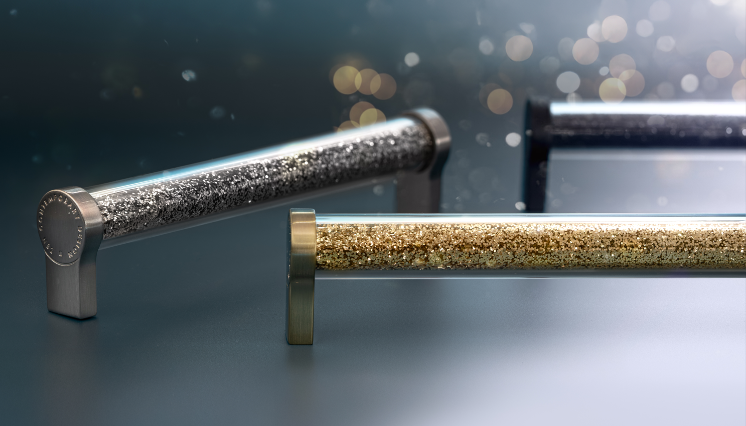
Caption: Richelieu’s customizable U-Design decorative pull tell your unique story

Richelieu’s U-Design turns a small detail into a personal expression of style. Fill its clear acrylic tube with confetti, beads or other tiny treasures that capture your most cherished memories and tell your story. More than just hardware, it’s the start of a design journey only you can create.

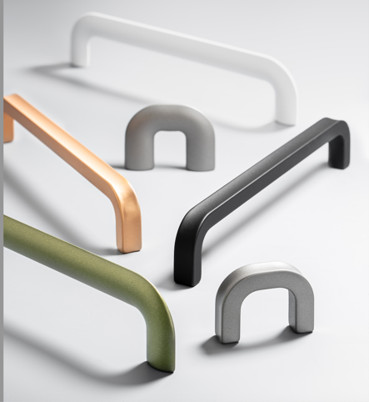
Caption: Richelieu’s Unicolor collection of decorative hardware

Defined by its ultra-slim profile, the Unicolor collection showcases refined Italian design with softly rounded corners for a comfortable, unobtrusive grip. Available in two sizes, finishes include the new Lecco Green and Agatha pink, which add a punch of color to modern design.

Premium Decorative Panels:
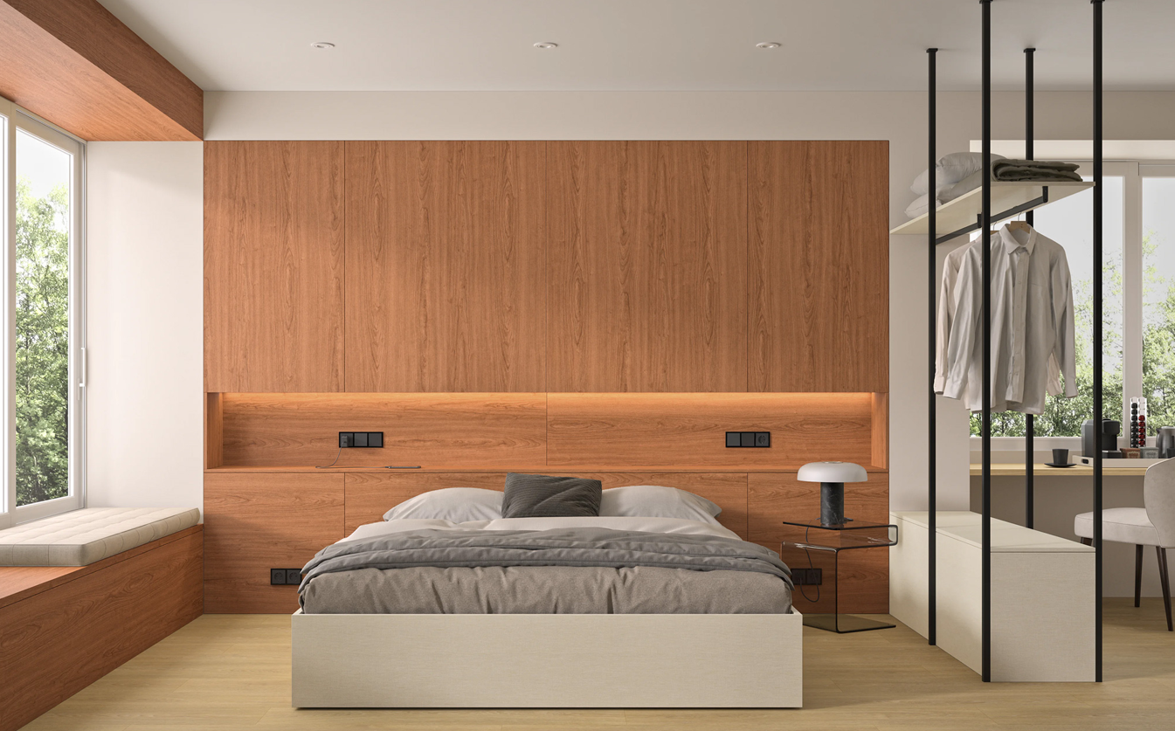
Caption: Richelieu’s Finsa Duo panels shown in Lino Esterio

Finsa Duo is a collection of high-quality textured panels, thoughtfully designed for both residential and commercial interiors. With a selection of 39 contemporary colors, natural woodgrains and linen textures, Finsa Duo offers the perfect balance of beauty, versatility and sustainability. Textile finishes such as Lino Esterio and Lino Nassau
bring soft, sophisticated style to closets and open living spaces.

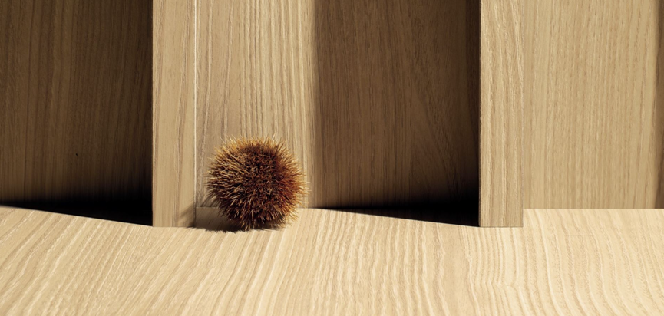
Caption: Richelieu’s Nature + Thermo-Structured Surface in Ramata finish

Nature + brings innovation and style together through an Italian designed Thermo-Structured Surface that delivers exceptional performance and visual appeal. Crafted in Italy, this highly durable, deeply textured surface is engineered to resist scratching and withstand sun exposure without fading, ensuring lasting beauty in any environment. With endless application possibilities, Nature + is launching 12 new distinctive colors, inspired by authentic natural wood grains and striking abstract motifs.

Cabinet Storage:
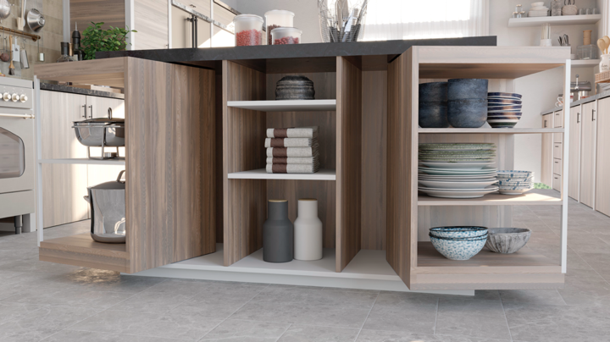
Caption: ORBIX 360-degree rotating cabinet from Richelieu

A finalist for “Best of KBIS: Best in Show” ORBIX is a 360-degree rotating system allowing cabinets to reveal or conceal interiors with a simple gesture. Closed, ORBIX offers a sleek, refined façade. Open, it showcases contents with elegance and style. This freedom of movement inspires bold, creative designs where a single piece of furniture can serve multiple purposes. Elegant innovative and versatile, ORBIX redefines the cabinet experience.

Open Storage Systems:
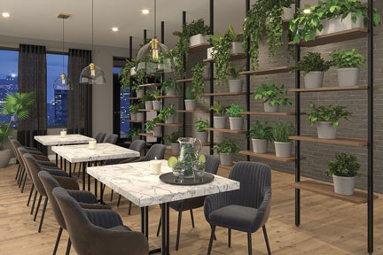
Caption: Richelieu’s LOGO III modular storage system

The LOGO III modular system can be customized to fit virtually any space with floor-to-ceiling or wall-mounted configurations. The system supports rods, shelves and drawer units, offering designers maximum flexibility.

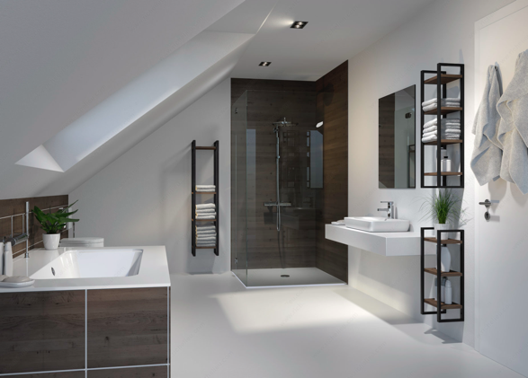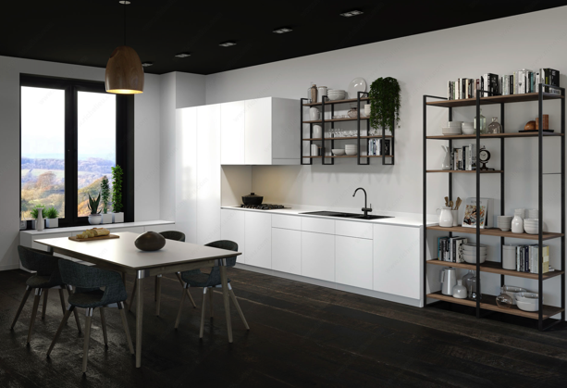
Caption: Richelieu’s YouK open shelving system

The YouK open shelving system features six modular configurations that adapt to nearly any interior project. Its contemporary aesthetic blends seamlessly into pantries, kitchens, bathrooms, living rooms and offices. Units may be installed directly on the floor or suspended on the wall, offering endless layout possibilities.

Sliding System Solutions:
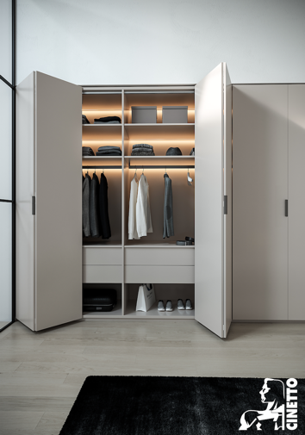
Caption: Richelieu’s PS23 Bifold Kit for tall bi-folding panels

The PS23 Bifold Kit is a clean, flexible solution for wide openings that require smooth, space-saving access. Designed for tall bi-folding panels, the system allows doors to fold neatly to one side, creating an open and organized look. Ideal for closets, wardrobes, pantries and large storage units, it delivers discreet design, fluid movement, and everyday ease for residential and light commercial interiors.

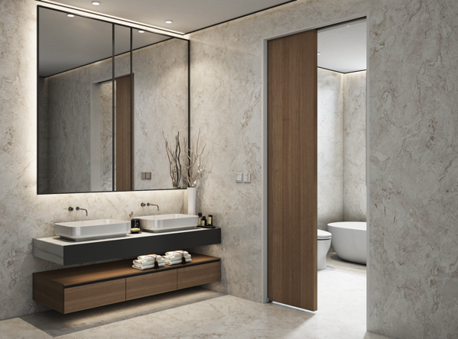
Caption: Richelieu’s Evanescence Pocket Door Kit

The Evanescence Pocket Door Kit provides an elegant and discreet sliding solution that maximizes space while maintaining a clean architectural look. Designed to disappear seamlessly into the wall, it makes interior spaces from bedrooms to offices to feel more open, fluid and uncluttered.

Multifunctional Magic:
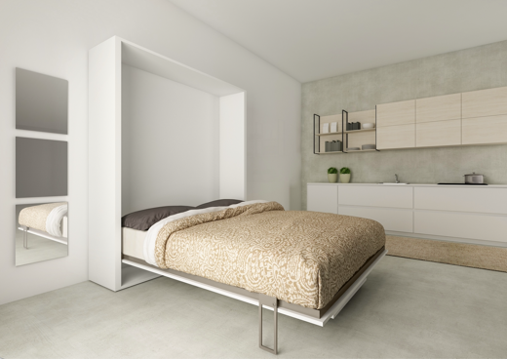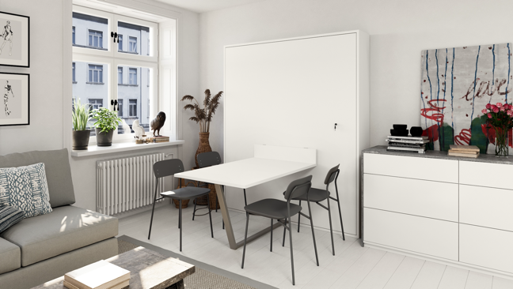
Caption: Richelieu’s Cielo system with Tabla mechanism and wall bed

A “Best of KBIS” finalist for “Most Functional Find,” Richelieu’s Tabla mechanism for the Cielo system makes studying, dining, entertaining and sleeping effortless—even in even the most compact living spaces. In seconds, the innovative table transforms into a comfortable sleeping space for the ultimate in multifunctional versatility.

Lighting for Every Environment:
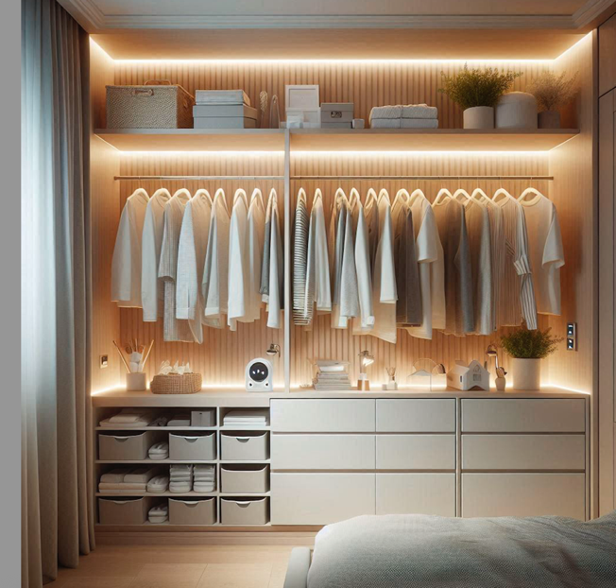
Caption: FlexyLED systems from Richelieu offer refined illumination

Richelieu’s FlexyLED systems provide seamless illumination for a refined look. The FlexyLED AT6 is a flexible linear module with silicone-encapsulated technology, delivering smooth “dot-free” light in a compact profile for recessed or surface installation. The FlexyLED SEH4 fits straight, curved, or circular grooves, integrating effortlessly into cabinetry and built-ins. Both systems are easy to install with pre-wired cables and deliver clean, minimalist lighting for any space.

Richelieu continues to redefine modern living with thoughtfully-designed, revolutionary solutions. The company’s commitment to quality, inclusivity, and forward-thinking design empowers homeowners, designers, architects and builders to transform interiors into functional, beautiful and enduring spaces.

About Richelieu
Richelieu is a leading North American importer, manufacturer, and distributor of specialty hardware and complementary products. An agent of change in a dynamic and creative industry, the company offers a broad mix of high-end, quality solutions for kitchens, bathrooms, closets, and cabinet storage. Richelieu’s products, sourced from worldwide manufacturers, serve a wide range of sectors including residential and commercial woodworking, furniture manufacturing, door, window, and hardware retailers, and renovation superstores.
###

