PRESS RELEASE
CONTACT:
Mary Beth Duehr: marybeth@duehrandassociates.com
Holly Berecz: holly@duehrandassociates.com
Duehr & Associates, LLC
1902 Wright Pl, Ste 200
Carlsbad, CA 92008
(760) 918-5622
Richelieu to Showcase Innovative Accessibility & Mobility Solutions at the 2026 Environments for Aging Conference + Expo
The company highlights inclusive, design-driven innovations that support independence and elevate everyday living
(Montreal, Canada, March 9, 2026) Richelieu Hardware is proud to announce its participation in the 2026 Environments for Aging Conference + Expo, taking place at the Phoenix Convention Center March 16-18. The event brings together designers, architects, and senior living professionals to explore the latest strategies for creating functional, attractive living environments that meet the evolving needs of an aging population.

Richelieu’s commitment to enhancing quality of life—without compromising aesthetics or performance—will be on full display at Booth 518 at this year’s expo. Accessibility, freedom of movement, and everyday independence are central to every thoughtfully designed solution in the company’s lineup. Each product is engineered to deliver fluidity, safety and comfort, ensuring individuals of all ages and mobility levels can navigate kitchens, bathrooms, and laundry rooms with ease.
Advancing Accessibility Through Design

A highlight of Richelieu’s presentation is its collaboration with Granberg, a renowned European manufacturer of accessible kitchen and living solutions. This partnership represents a significant step forward in bringing inclusive, design-driven innovation to the North American market.

Featured products include:
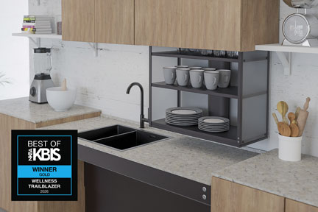
Richelieu’s VERTI 840 motorized lift for upper cabinets

Gold Winner of the 2026 Best of KBIS Awards for “Wellness Trailblazer,” the VERTI 840 Motorized Lift for upper cabinets safely and smoothly lowers overhead storage to an accessible height, improving reach and reducing strain.

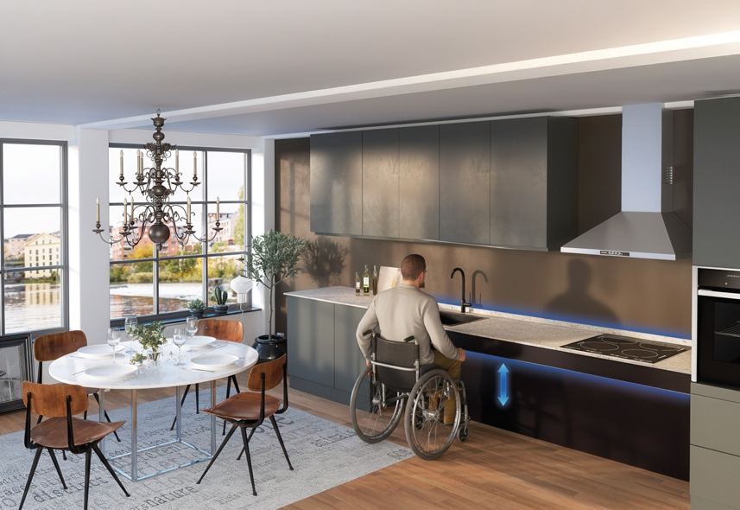
Richelieu’s Baselift 6600 height-adjustable worktop system

The Baselift 6600 Height-Adjustable Worktop System enables countertops to be raised or lowered to accommodate seated or standing users, supporting ergonomic flexibility.

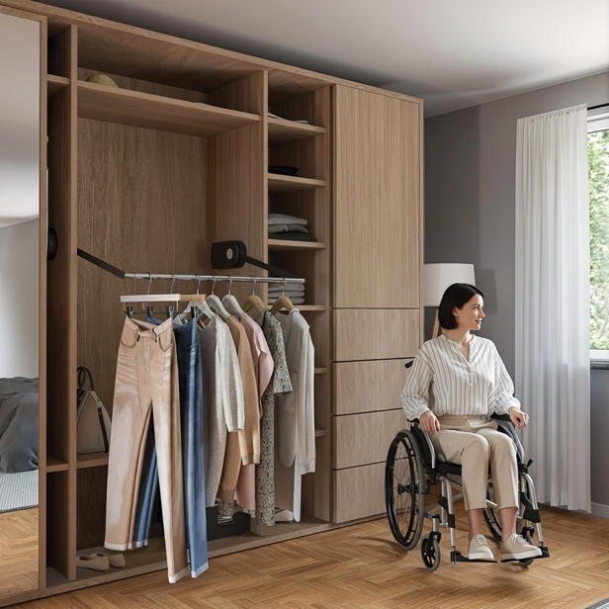
Richelieu’s Butler 730 pushbutton wardrobe lift. Only available through special order.

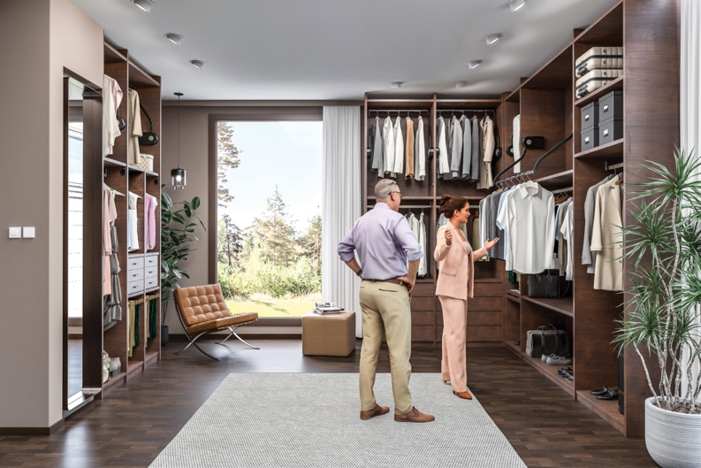
Richelieu’s Butler 732 pushbutton wardrobe lift

The Butler 730 and Butler 732 pushbutton wardrobe lifts transform the closet for enhanced accessibility. Raise and lower clothing with the push of a button, keeping your wardrobe organized and within easy reach. Ideal for seated users, the Butler 730 replaces a fixed clothes rail, bringing clothing down and forward for easy access. Meanwhile, the Butler 732 maximizes overhead closet space, allowing room for extra storage, an additional rail or shelving below.

In addition, Richelieu will showcase more solutions that transform spaces into inclusive environments that meet evolving standards and expectations for safety, accessibility, comfort, and long-term independence in aging-focused communities.

Flexible Kitchen Solutions

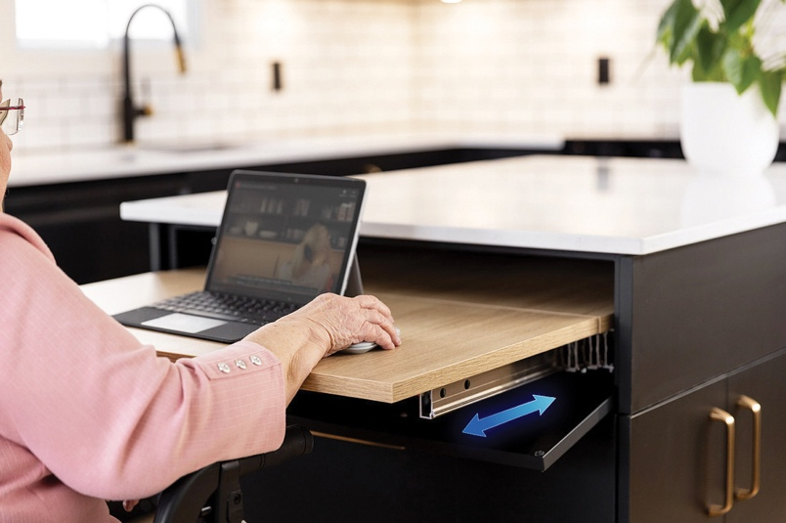
Richelieu’s Plus II table extension mechanism

The Plus II Table Extension Mechanism allows users to adapt to their environment as mobility, strength, or standing endurance changes. Discreetly concealed within a drawer space, the surface pulls out and unfolds to create ergonomic work or dining areas, then tucks away seamlessly when not in use. Ideal for kitchens, offices, laundry rooms, bathrooms, and multi-purpose spaces, Plus II is designed to reduce physical strain while promoting independence and aging in place.

Sliding Systems for Safer Movement
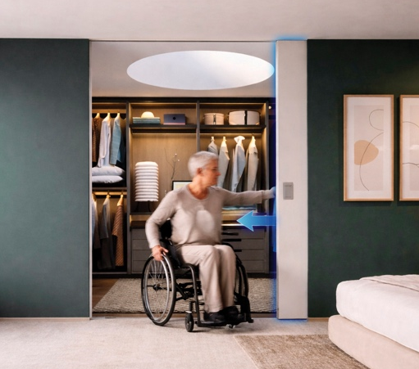
Richelieu’s HAWA Junior 100B ADA-compliant sliding doors

The HAWA Junior 100 B is an ADA-compliant, soft-close, top-hung sliding door system designed for seamless accessibility. Its recessed suspension plate ensures minimal clearance between the door and the track, delivering both contemporary design integration and improved ease of use.

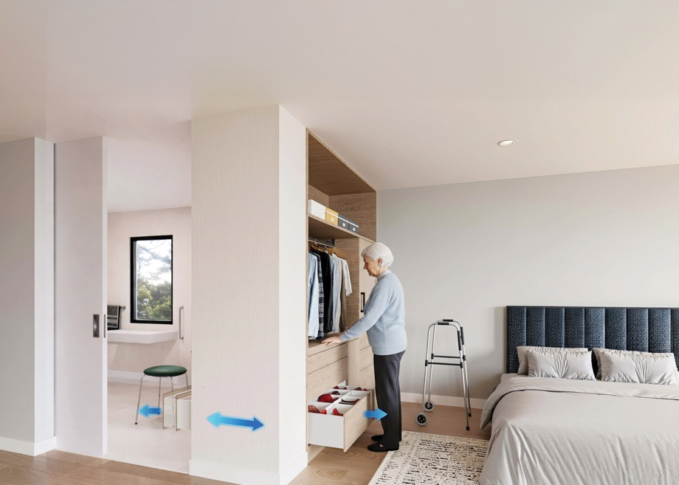
Richelieu’s Riverso bidirectional sliding system

The Riverso bidirectional sliding system further optimizes space and enhances ergonomics. With silent soft-close and push-to-open functionality, Riverso enables access from either side—improving traffic flow, supporting safer movement, and reducing the risk of injury.

ADA-Compliant Support and Hardware Solutions

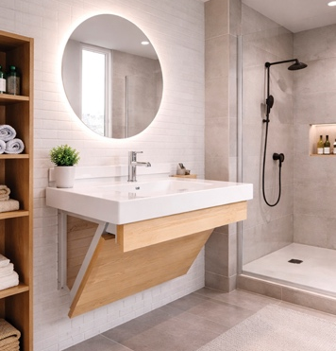
Richelieu’s ADA Kolossus vanity support bracket

The ADA Kolossus Vanity Support Bracket provides the necessary clearance to comply with accessibility standards, making daily use easier for wheelchair users while maintaining a clean, modern aesthetic.

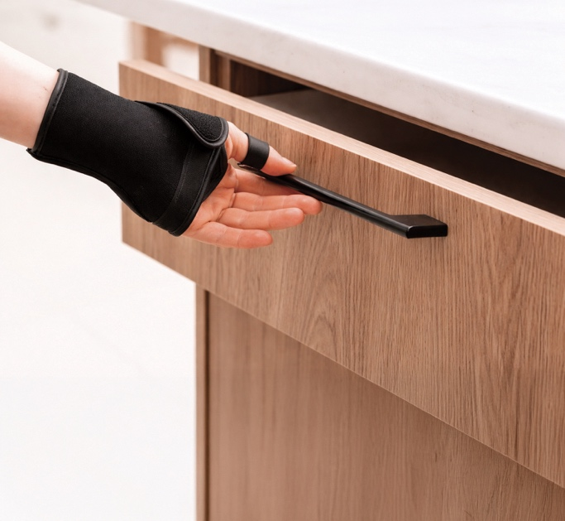
Richelieu’s ADA-Compliant Decorative Hardware

Richelieu’s ADA-Compliant Decorative Hardware is designed with ergonomics in mind. These thoughtfully engineered handles and pulls allow cabinet doors and drawers to open easily with one hand—without twisting the wrist or requiring tight grasping or pinching. Available in a wide range of styles, finishes, and sizes, they combine aesthetic appeal with inclusive performance.

Smart Lighting for Healthy Aging
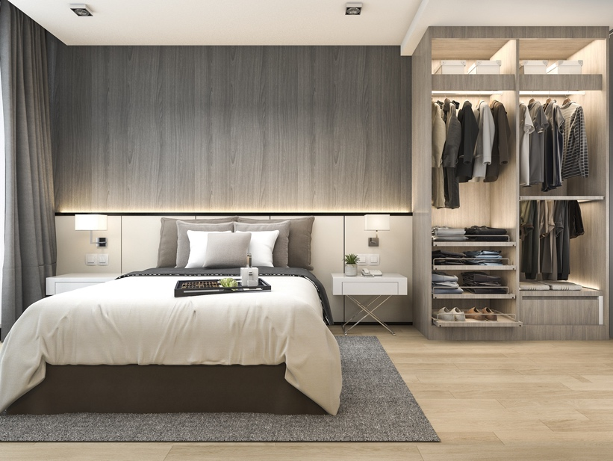
Richelieu’s Smart Control Lighting Box

Richelieu’s Smart Control Lighting Box features wireless connectivity and compatibility with smartphones and voice activated systems, enabling users to customize lighting for optimal visual comfort. Lighting that mimics natural daylight may help reduce falls, improve mood, and promote better sleep—supporting healthy aging at home, particularly for individuals with impaired vision.

From adaptive kitchens and ergonomic sliding solutions to smart lighting and ADA-compliant hardware, Richelieu’s presence at the 2026 Environments for Aging Conference + Expo underscores how thoughtful innovation can empower independence and dignity at every stage of life. To learn more about Richelieu’s full range of mobility and accessibility solutions, visit: https://www.richelieu.com/ca/en/category/accessibility-and-mobility-solutions/2695050

Attendees are invited to visit Richelieu, Booth 518, at the Phoenix Convention Center and discover how accessible design can evolve to meet the needs of every generation.

About Richelieu
Richelieu is a leading North American importer, manufacturer, and distributor of specialty hardware and complementary products. An agent of change in a dynamic and creative industry, the company offers a broad mix of high-end, quality solutions for kitchens, bathrooms, closets, and cabinet storage. Richelieu’s products, sourced from worldwide manufacturers, serve a wide range of sectors including residential and commercial woodworking, furniture manufacturing, door, window, and hardware retailers, and renovation superstores.

###

