PRESS RELEASE
CONTACT:
Mary Beth Duehr: marybeth@duehrandassociates.com
Holly Berecz: holly@duehrandassociates.com
Duehr & Associates, LLC
1902 Wright Pl, Ste 200
Carlsbad, CA 92008
(760) 918-5622
Elevating Glass Design: Richelieu Glazing Divisions Unveil Architectural Innovations at Top Glass 2026
From structural glass systems to refined architectural details, Richelieu highlights solutions that merge performance, precision, and contemporary design
(Montreal, Canada, April 22, 2026) Richelieu Hardware is proud to announce that two of its specialized divisions, Richelieu Glazing Supplies (booth 20) and Euro Architectural Components (booth 21) will exhibit at the Top Glass Conference & Trade Show on April 30, 2026, at the International Centre in Mississauga, Ontario, Canada. Recognized as one of the glass and fenestration industry’s premier annual events, Top Glass offers a dynamic platform for innovation, networking, and professional development across North America.

For more than a decade, Top Glass has brought together glazing contractors, glass fabricators, architects, and façade designers for an immersive experience focused on building with glass. Richelieu’s participation underscores its ongoing commitment to supporting the North American market with advanced solutions, technical expertise, and design-driven innovation.

At this year’s event, Richelieu Glazing Supplies and Euro Architectural Components will showcase a curated range of high-performance glazing and architectural hardware solutions, including:
HD Series Spider Fittings
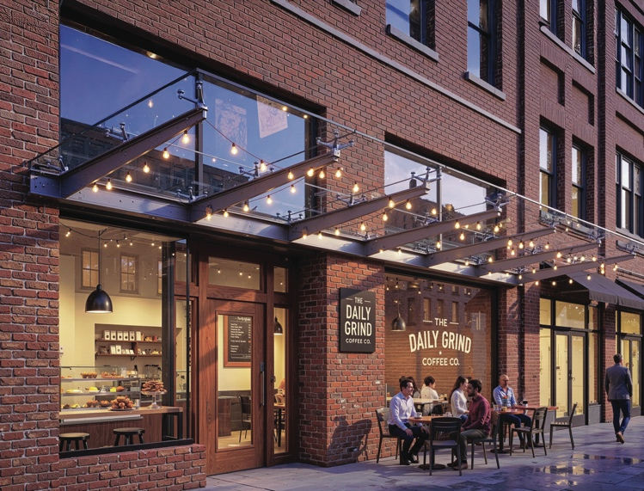
Caption: HD Series Spider Fittings

The HD Series Spider Fittings deliver strength and clarity for point-supported glass systems, creating expansive, transparent facades with minimal visual obstruction. Perfect for stairs, balconies, facades, and canopies, they offer a clean, streamlined look with maximum design flexibility for both interior and exterior spaces.

S1 Side Mount Elite Posts
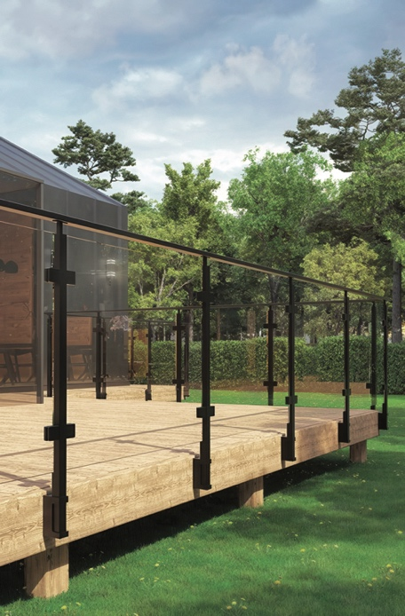
Caption: S1 Side Mount Elite Posts

S1 Side Mount Elite Posts offer a sleek, modern solution for stairs and railings, building strength with a clean, minimalist design. Available in Powder Coated Black and Satin Stainless Steel, the posts are designed for easy installation. They create a streamlined, contemporary look that complements any interior or exterior space.

Minimalist Patch Fittings
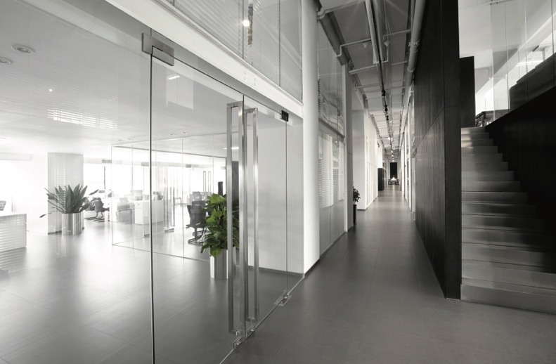
Caption: Minimalist Patch Fittings

Minimalist Patch Fittings offer a sleek, durable solution for interior glass doors, combining function with a clean, modern aesthetic.

Riveo Oasis Sliding Shower Door System
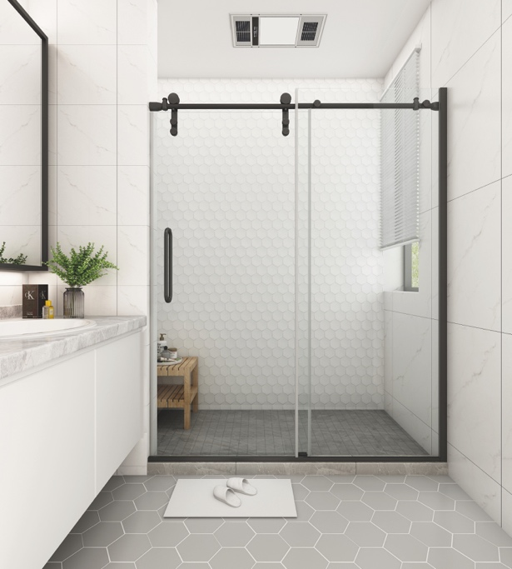
Caption: Riveo Oasis Shower Door Kit

The Riveo Oasis Kit is a contemporary sliding door system that blends function and elegance. Available in black or chrome, it’s designed to optimize space while creating a refined, spa-like bath environment. With a modern, minimalist aesthetic, this framed solution seamlessly installs over a bathtub or shower base, offering a sleek alternative to cumbersome shower curtains.

Top Glass is an important opportunity to connect with industry professionals across North America and highlight the innovation driving today’s glazing and architectural solutions. The line-up of products not only meet evolving performance standards but also elevate design possibilities.

Attendees are invited to visit Richelieu Glazing Supplies and Euro Architectural Components at booths 20 and 21 to meet with product specialists and explore the latest advancements in glazing systems and architectural hardware.

About Richelieu
Richelieu is a leading North American importer, manufacturer, and distributor of specialty hardware and complementary products. An agent of change in a dynamic and creative industry, the company offers a broad mix of high-end, quality solutions for kitchens, bathrooms, closets, and cabinet storage. Richelieu’s products, sourced from worldwide manufacturers, serve a wide range of sectors including residential and commercial woodworking, furniture manufacturing, door, window, and hardware retailers, and renovation superstores.
###

