PRESS RELEASE
CONTACT:
Mary Beth Duehr: marybeth@duehrandassociates.com
Holly Berecz: holly@duehrandassociates.com
Duehr & Associates, LLC
1902 Wright Pl, Ste 200
Carlsbad, CA 92008
(760) 918-5622
Richelieu Showcases Innovative Solutions at 2026 Furniture Manufacturing Expo
From advanced lighting systems to precision hardware and drawer technologies, Richelieu’s new products help manufacturers elevate furniture design, craftsmanship, and manufacturing efficiency
(Montreal, Canada, June 03, 2026) Richelieu Hardware will introduce its latest innovations for the furniture manufacturing industry at the upcoming Furniture Manufacturing Expo, taking place June 3-4, 2026 at the Charlotte Convention Center in Charlotte, North Carolina. At Booth #810, furniture manufacturers, designers, engineers, and production professionals can explore a comprehensive collection of hardware, lighting, fittings, and furnishing solutions engineered to support today’s evolving manufacturing demands—all while enhancing the quality, aesthetics, and market appeal of finished furniture.

Bringing together the largest gathering of companies that produce, design, develop and manufacture products and equipment, the expo enables designers, engineers, executives, plant managers, machine operators, purchasing managers, and more to gain a fresh perspective on the furniture manufacturing industry. Over two days, attendees will have the opportunity to engage with suppliers, network with industry leaders, learn from experienced professionals, and experience the latest solutions available to furniture manufacturers.

Richelieu’s newest introductions are designed to blend refined aesthetics with expanded capabilities, elevating every detail of modern furniture. New products include advanced lighting systems, precision drawer systems, and stylish-yet-practical furniture legs. Richelieu’s innovations allow furniture designers and manufacturers to create more cohesive, highly customized spaces with thoughtfully integrated finishing details.

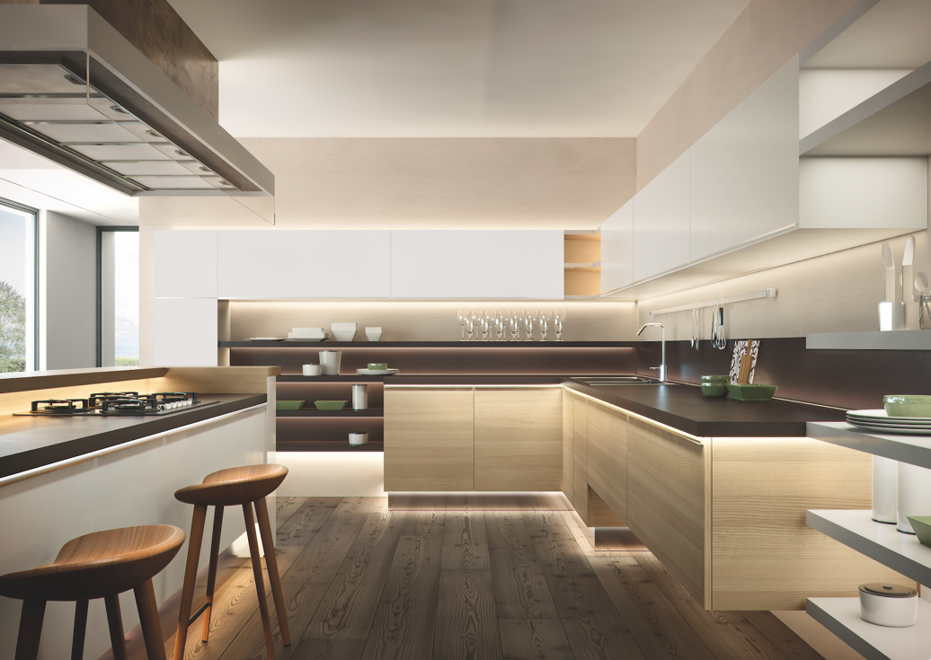
FlexyLED

Lighting That Defines Ambiance
The right lighting has the power to transform a space. Thanks to the visual depth created through lighting, it has evolved into a dynamic design element that defines mood, warmth, and the overall atmosphere while enhancing a space’s sense of luxury. Richelieu’s intelligent lighting solutions include innovative WAVE technology, designed to create seamless transitions between lighting tones while giving users intuitive control over their environment.

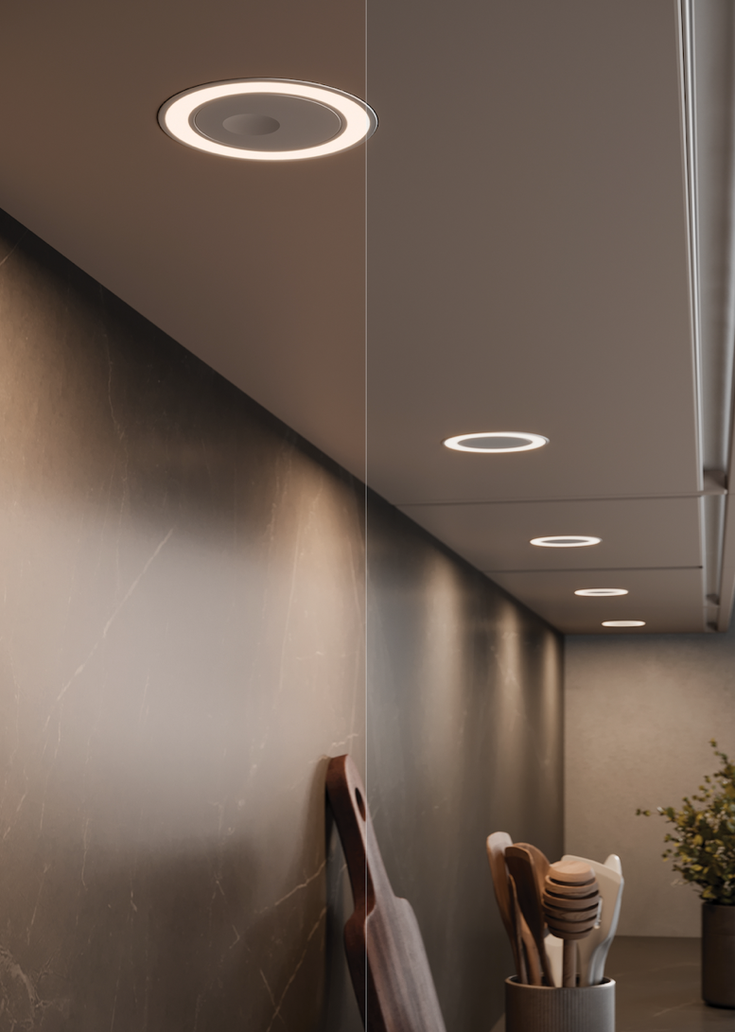
HOLL D-Motion Wave

WAVE elements include the FlexyLED HE6B D-Motion Wave, a dimmable dual-white LED strip ideal for dynamic underlighting applications, and the HOLL D-Motion Wave, which delivers distinctive halo-patterned illumination perfect for under-cabinet installations. Additional versatile solutions such as the FlexyLED SEH4 and FlexyLED AT6 offer customizable cut lengths for precise integration beneath cabinetry and along curved surfaces. The lighting elements are compatible with the 96W Wireless Bluetooth BTRF LED Receiver, a fully wireless solution that offers convenient Bluetooth-enabled lighting control for added convenience and customization.
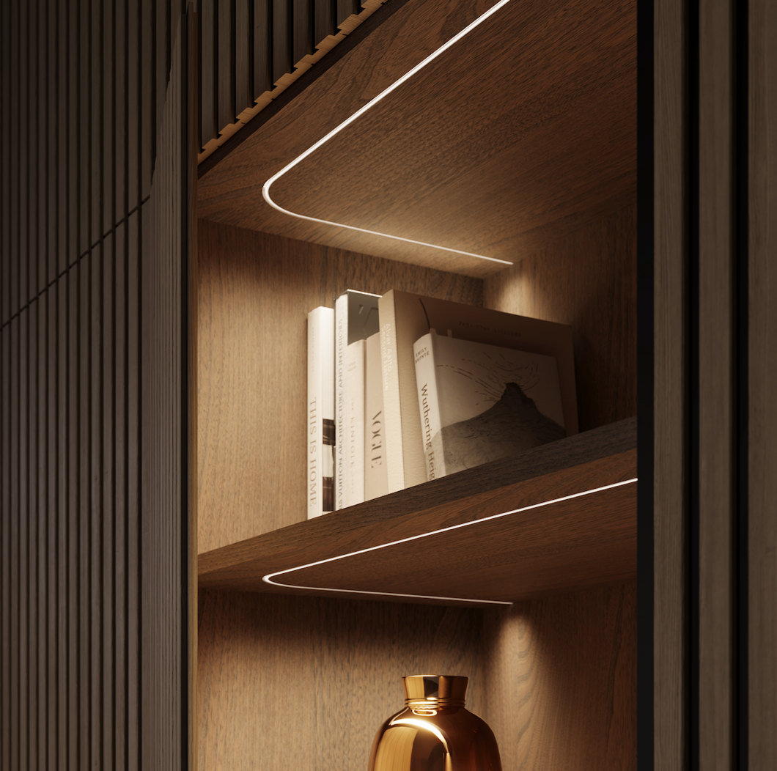
FlexyLED SEH4

High-Performance Drawer Hardware
In today’s cabinetry, exceptional function is just as important as a refined look. Richelieu’s advanced drawer systems deliver smooth, effortless motion, long-lasting performance, and streamlined design details that enhance the comfort and experience of everyday living. Among the featured solutions is the Series 828 Full-Extension Synchronized Concealed Undermount Slide, engineered with synchronized soft-close technology for whisper-quiet operation and exceptional stability. The synchronized mechanism helps prevent drawer twisting and bending, ensuring a smooth, even glide regardless of where the drawer is pulled.

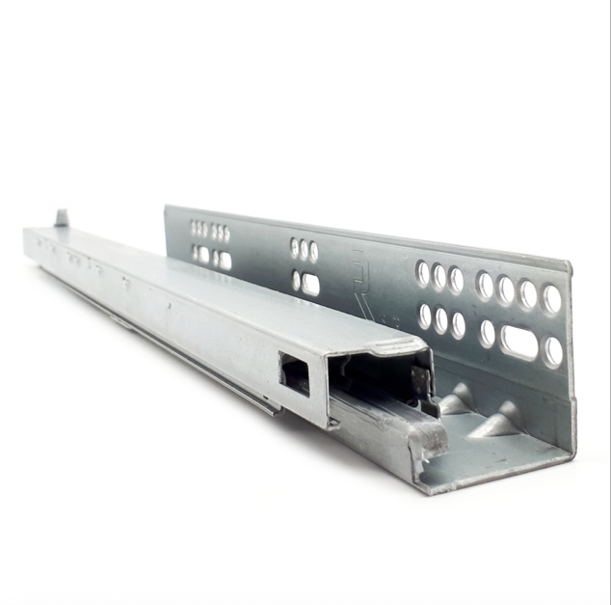
Series 828 Full-Extension Synchronized Concealed Undermount Slide

For projects requiring a more value-driven solution without compromising quality, the 314 F Series Concealed Drawer Slide delivers dependable soft-close performance with a practical ¾ extension suitable for a wide range of cabinetry applications. Complementing the slide systems is the RCS 105-degree Gotham Metallic soft-close hinge, which pairs a refined metallic black finish with timeless style.

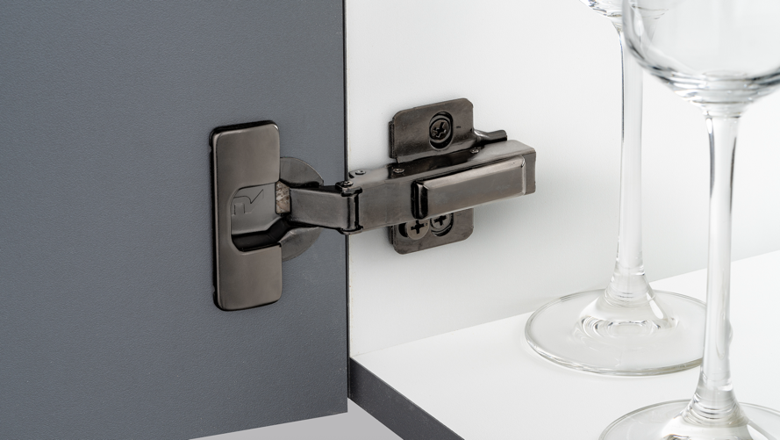
RCS 105-degree Gotham Metallic soft-close hinge

To further enhance safety and convenience, Richelieu presents the SVS Interlock System Assembly. Designed to prevent the simultaneous opening of multiple drawers, it’s an essential childproofing feature that reduces dangerous tip-overs. Also featured is the Locking Device for Richelieu 828 Slides, a thoughtful and discreet safety enhancement for family-safe design.
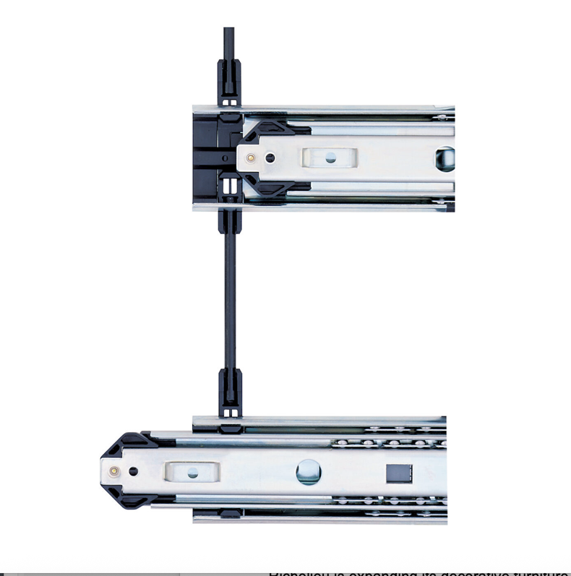
SVS Interlock System Assembly

Designer Furniture Legs for Refined Interiors
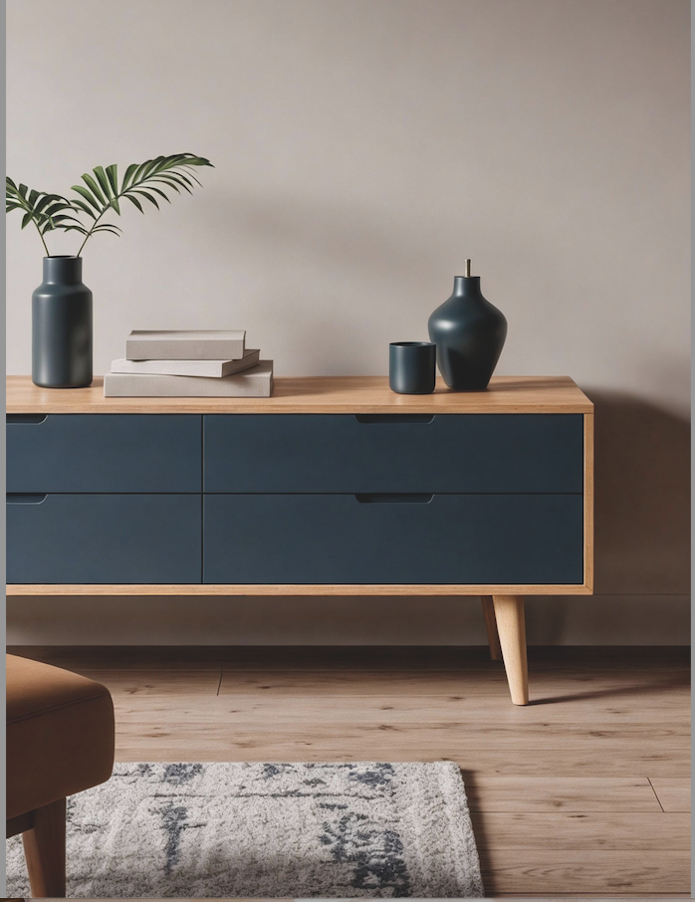
Richelieu’s wooden furniture legs

Richelieu is expanding its decorative furniture offerings with a collection of designer furniture legs in an array of styles and materials including wood and metal. RIALTO furniture legs, designed to bring sculptural detail and refined sophistication to modern interiors. Defined by clean architectural lines and elevated finishes, the collection transforms cabinetry and furniture into statement-making design features while adding a distinctive custom feel to kitchens, baths, closets, and living spaces.

Richelieu will showcase an array of contemporary furniture leg solutions designed to complement today’s modern interiors. The steel Tapered Bench Legs bring industrial-inspired styling to benches and narrow coffee tables while the Design Furniture Leg for sofas, upholstered chairs, cabinets, and dressers adds personality to modern, minimalist, or contemporary styles. It’s easy to install, offers height adjustment and is available in aluminum, chrome, and dark brown finishes.

Perfect for modern wood or upholstered furniture, the 120 mm Design Furniture Leg by designer Giuseppe Bavuso adds sleek Italian-inspired style.

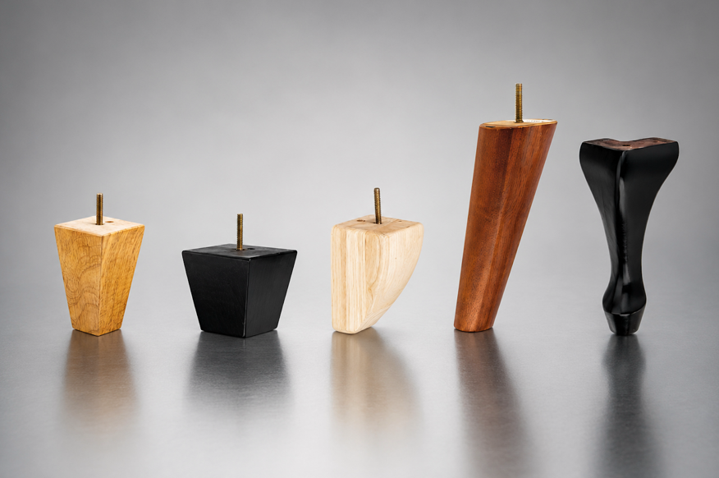
Richelieu’s array of wooden furniture legs

For added adaptability, Richelieu’s Adjustable Furniture Leg 555 offers a sleek minimalist aesthetic with up to 20 mm (3/4”) of height adjustment. It’s ideal for sofas, cabinets, vanities, dressers, and other furnishings. Available in aluminum and dark brown finishes, the legs combine easy installation with refined modern styling.

Casters that Keep Good Design on a Roll
Richelieu offers a broad range of industrial casters designed to meet a variety of needs. The new Moebius series by Starck features perfectly aligned design lines for a look of continuity, not to mention ultra-smooth performance.
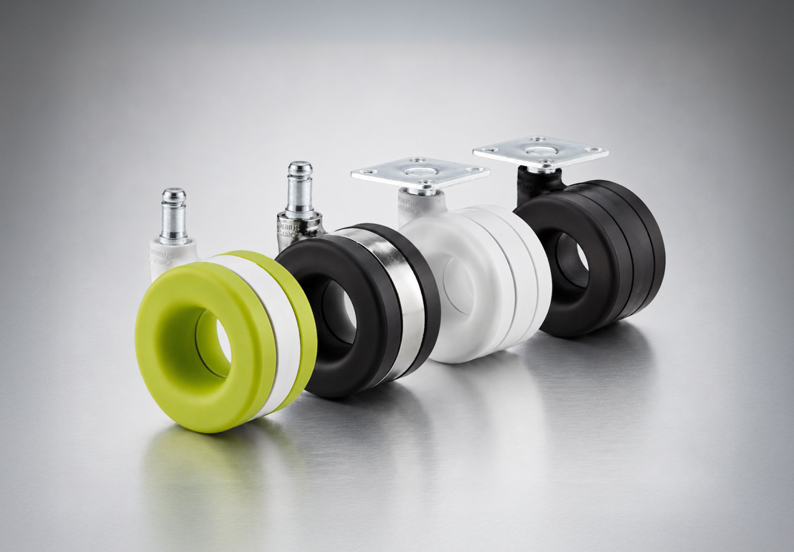
Moebius series by Starck

Complete Solutions for Luxury Craftsmanship
Richelieu’s product portfolio extends beyond hardware and fittings to include premium finishing products and professional-grade shop supplies that help craftsmen achieve the highest standards of quality and luxury.

Featured finishing solutions include Mohawk Finishing Products for wood and leather surfaces, alongside premium tools and shop supplies form trusted industry names such as Bosch and Festool. Together, these offerings reflect Richelieu’s ongoing commitment to innovation, craftsmanship, and sophisticated furniture manufacturing.

Event Details:
Furniture Manufacturing Expo
Charlotte Convention Center
501 S College St.
Charlotte, NC 28202
Wednesday, June 3, 2026 from 10am-5pm and Thursday, June 4 from 10 am to 4pm
Visit Richelieu at Booth #810.

About Richelieu
Richelieu is a leading North American importer, manufacturer, and distributor of specialty hardware and complementary products. An agent of change in a dynamic and creative industry, the company offers a broad mix of high-end, quality solutions for kitchens, bathrooms, closets, and cabinet storage. Richelieu’s products, sourced from worldwide manufacturers, serve a wide range of sectors including residential and commercial woodworking, furniture manufacturing, door, window, and hardware retailers, and renovation superstores.
###

