PRESS RELEASE
CONTACT:
Mary Beth Duehr: marybeth@duehrandassociates.com
Holly Berecz: holly@duehrandassociates.com
Duehr & Associates, LLC
1902 Wright Pl, Ste 200
Carlsbad, CA 92008
(760) 918-5622
Richelieu Brings Innovation and Design Versatility to the 2026 Closets Conference & Expo
Showcasing new decorative hardware, lighting, surfacing, and storage solutions, Richelieu empowers designers to create highly personalized, beautifully organized spaces
(Montreal, Canada, July 01, 2026) Richelieu Hardware will introduce its latest solutions for creating stylish and functional custom closets at the Closets Conference & Expo taking place June 30 through July 2, 2026 at the Palm Beach County Convention Center in West Palm Beach, Florida. At Booth #405, designers, architects, fabricators, retailers, installers, contractors, developers, custom builders, and manufacturers can explore a comprehensive collection of decorative hardware, decorative panels, storage systems, closet accessories, door systems, lighting and more, all designed to create highly customized closets, garages, and home storage systems.

The only national event for closets and home organization, the Closets Conference & Expo brings together more than 1,300 industry professionals for education and information on products to help create their clients’ most challenging spaces.

This year, Richelieu’s newest introductions include sophisticated door systems, sleek panels, organizing accessories, decorative hardware and integrated lighting. Able to transform any space with style and purpose, the latest innovations redefine what’s possible in the world of organization and storage. The following products, and more, will be on display at the expo:

Satin Brass Collection Brings Distinctive Elegance
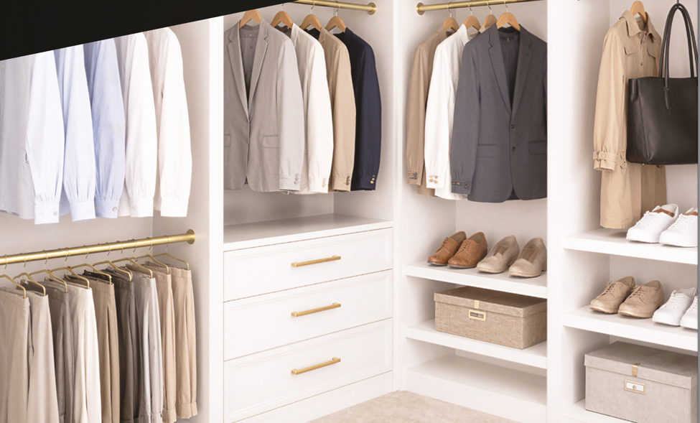
Richelieu’s Satin Brass Collection brings cohesive design to the closet with a fully coordinated selection of accessories and finishing details in a warm, sophisticated finish

In today’s interiors, thoughtful coordination transforms a well-designed space into a truly refined environment. Richelieu’s Satin Brass Collection offers a cohesive design solution that unifies hardware, storage accessories, and lighting through a warm finish with a soft, sophisticated sheen. Extending seamlessly from pulls, knobs, hooks, shoe rails, belt and tie racks, and valet rods to closet rods, jewelry trays, drawer side panels, and integrated lighting, the collection creates visual continuity that guides the eye effortlessly from one element to the next. The result is a harmonious, elevated aesthetic where every detail works together to create a balanced and intentional design statement.

Distinctive Decorative Hardware
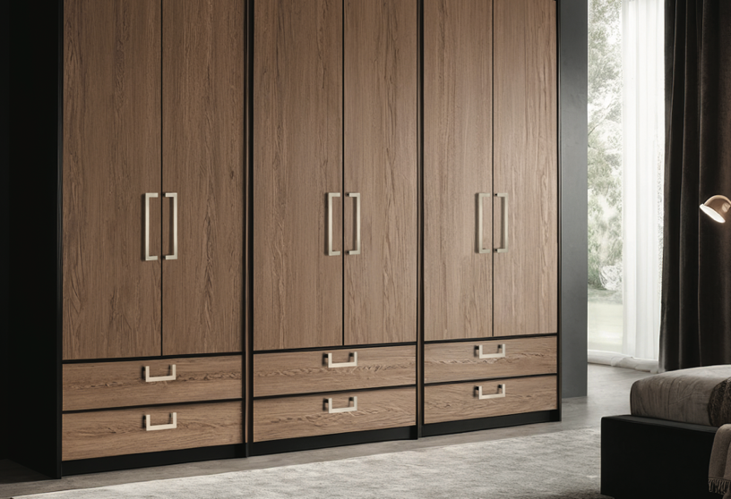
Richelieu’s extensive decorative hardware collection includes sleek, minimal designs for the modern home

Richelieu’s new collection of decorative hardware spans the range of styles from traditional to contemporary, giving designers and homeowners an extensive range of options for closets, cabinetry, furniture, appliances, and more. From clean modern lines to timeless traditional detailing, each piece is designed to articulate a personal aesthetic while meeting the highest standards of quality and durability. With designs in five distinct style categories—Modern, Transitional, Traditional, Eclectic, and Functional—the collection makes it easy to find hardware that complements any design direction.

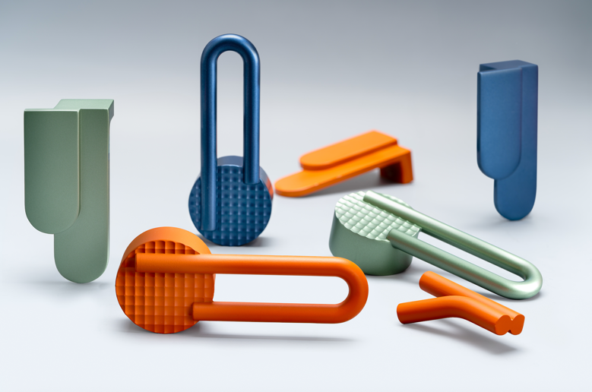
Richelieu’s Atipica hardware, designed by Gianmarco Codato and Luciano Trevisiol

Designed by Gianmarco Codato and Luciano Trevisiol, the Atipica designer hardware collection lets designers add character and identity to any project. Derived from the Italian word for “atypical,” Atipica is defined by eccentric geometric shapes and textures.

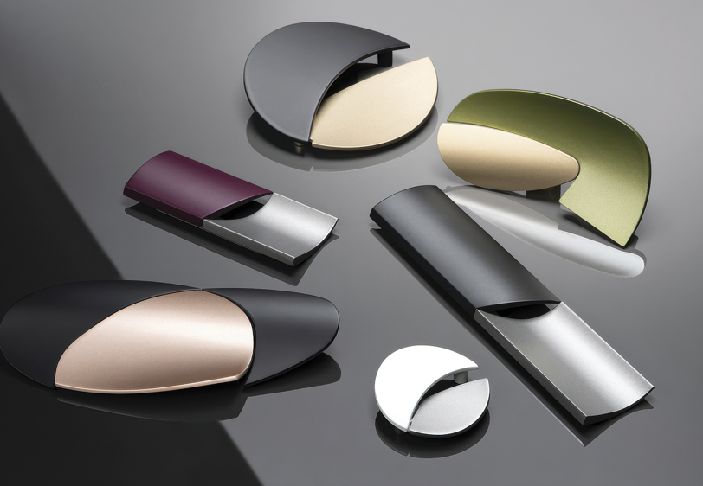
Richelieu’s geometric-inspired Alba hardware collection

The Alba Collection brings high-end Italian design to wardrobe cabinets and doors in this series of innovative geometric knobs and pulls. It pairs bold on-trend colors, such as plums and hot pinks, with understated greys and blacks that are punctuated by unexpected cut-outs and a dialogue between convex and concave volumes.

High-Performance Panels and Surfacing
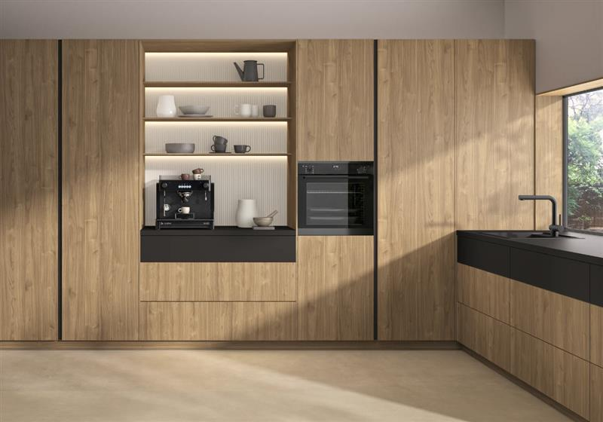
Richelieu’s Finsa Duo panels shown in Nogal Slow

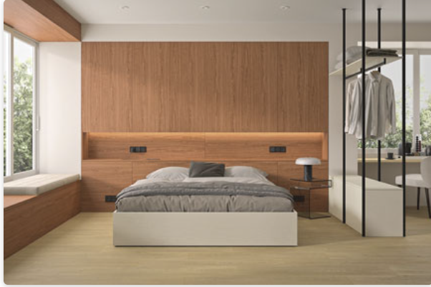
Richelieu’s Finsa Duo panels shown in Lino Esterio

Finsa Duo is a collection of thoughtfully designed, high-quality textured panels. With a selection of 39 contemporary colors, natural woodgrains and linen textures, Finsa Duo brings the perfect balance of beauty and versatility to closets, and beyond.

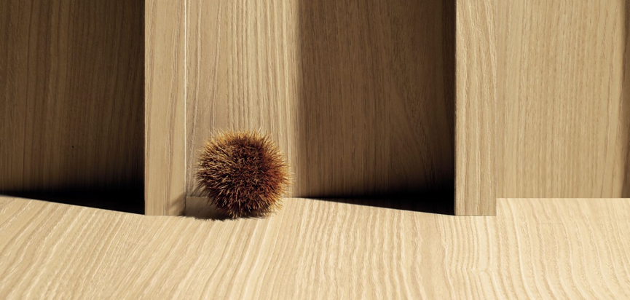
Richelieu’s Nature + Thermo-Structured Surface in Corteccia

Nature + brings innovation and style together through an Italian designed Thermo-Structured Surface that delivers exceptional performance and visual appeal. Crafted in Italy, this highly durable, deeply textured surface is engineered to resist scratching and withstand sun exposure without fading, ensuring lasting beauty in any environment. Perfect for the closet, and virtually any residential or commercial space, Nature + is offered in an array of distinctive finishes inspired by authentic natural wood grains and striking abstract motifs.

Optimized Open Closet Systems
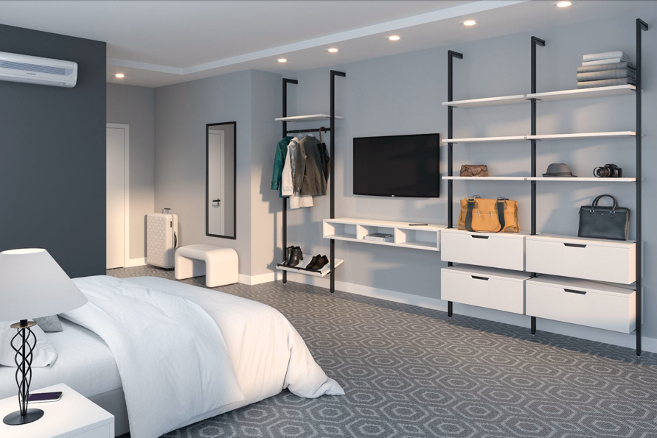
Richelieu’s flexible LOGO III closet system

For those looking to optimize their storage and get organized, the Logo III closet system offers flexible, modular storage solutions that can be customized for any project. Made of aluminum profiles that are perfect for wall and ceiling installation, this system can be cut to different dimensions to fit its intended space. Available in two trendy finishes, matte gray and matte black, the Logo III provides a modern aesthetic in a practical system of supports to keep clutter at bay and disorganization a thing of the past.

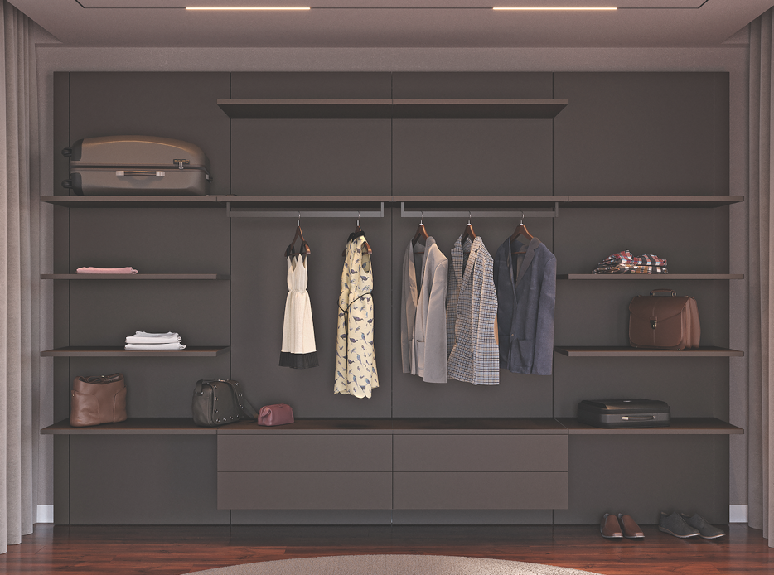
Richelieu’s fully customizable VERTIKO closet system

The VERTIKO closet system brings refined storage to life with a clean, modern aesthetic and fully customizable configurations. Its concealed aluminum profiles offer a minimalist look that adapts effortlessly as your needs change. Shelf and cabinet supports slide into narrow profile channels, allowing for quick and easy repositioning as needs change.

Convenient Closet Accessories
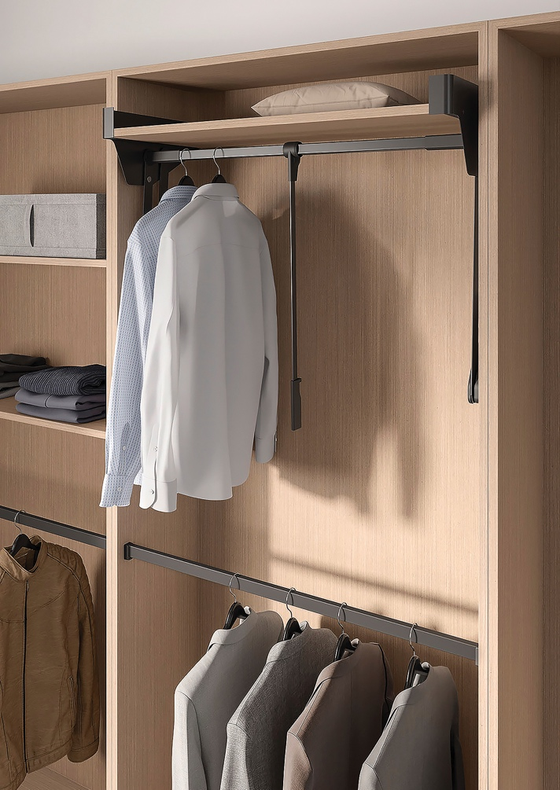
Richelieu’s CONERO pull-down closet rod

Richelieu’s CONERO Pull-Down Closet Rod makes it easy to utilize your closet’s full vertical potential. The pull-down rod allows for easy access to clothing stored in higher spaces and also frees up lower closet space for a more streamlined and organized storage layout. The width-adjustable rod ensures a precise fit in various cabinet sizes while the self-balancing assist and soft-close mechanisms provide smooth, secure and quiet operation every time.

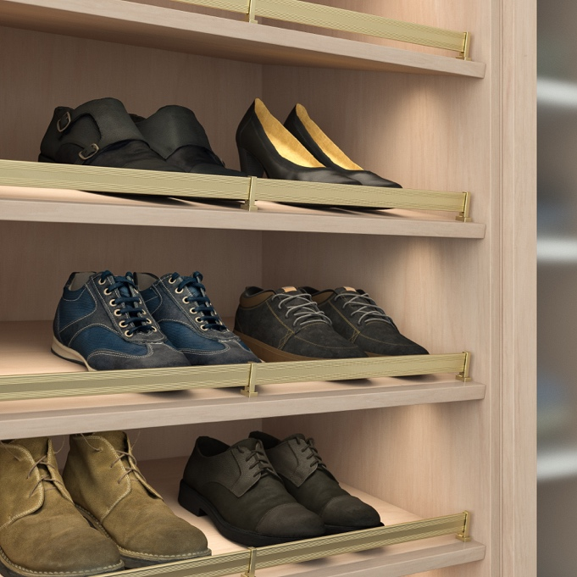
Richelieu’s Design-R collection shoe rails

From pull-out tie, scarf, and belt racks to shoe rails and valet rods, Richelieu’s Design-R collection of closet accessories takes organization to the next level. The pull-out racks are easy to install and perfect for optimizing storage space in tighter quarters. The elegant shoe rails can be installed on an inclined shelf in a closet cabinet and are available in four trendy finishes, including Polished Chrome, Matt Nickel, Matt Black and Satin Brass.

Smooth Operating Door Systems
The CINETTO PS23 bifold kit with track is designed for two or four tall wood-panel doors that fold to the left or right. Supporting up to 110 pounds, the system offers smooth, reliable operation and an optional push-to-open feature for added convenience. Its simple, flexible, and cost-effective installation makes it an ideal solution for closets, wardrobes, pantries, and large storage areas.

Space-saving Bed System
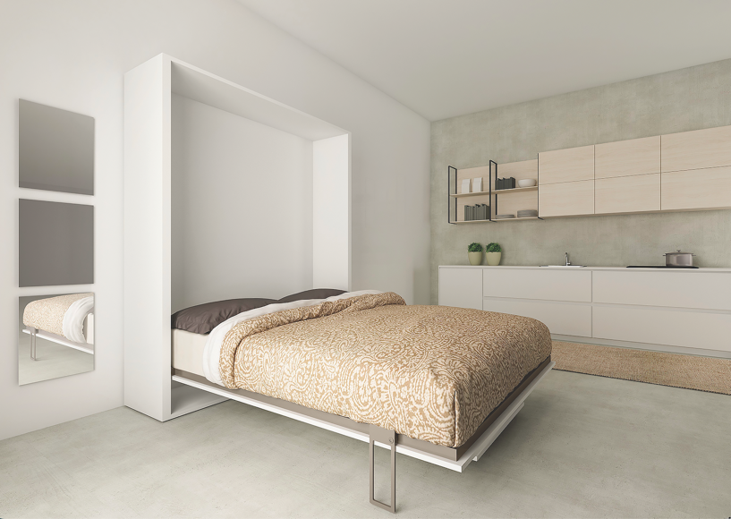
Richelieu’s space-saving CIELO bed-in-a-box

Smart, compact, effortless—that’s Richelieu’s CIELO bed-in-a-box. Designed to maximize space, the vertical wall bed ships in two compact boxes that are easy to transport and maneuver. Quick and simple to assemble, it features piston-assisted technology for smooth, controlled, and secure operation when opening and closing. Self-opening legs deploy automatically in one fluid motion, making setup fast, easy, and hassle-free. CIELO is an ideal solution for spaces where fully assembled bed frames cannot fit, such as apartments with elevators, narrow hallways, or tight stairwells.

Lighting That Defines Ambiance
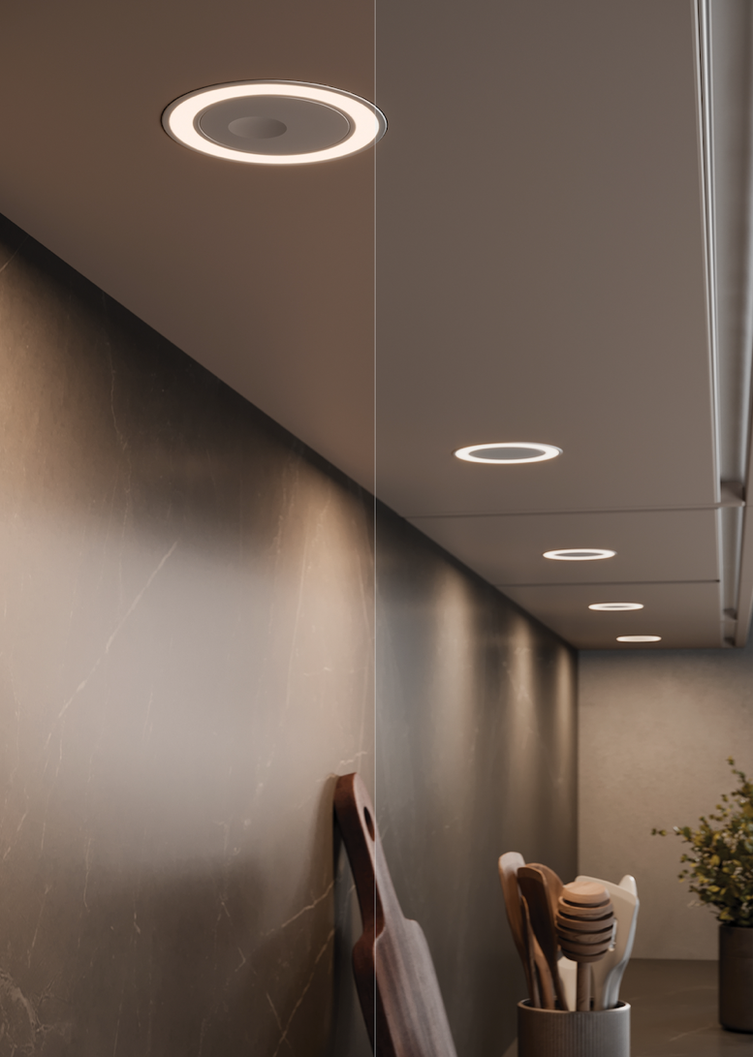
Richelieu’s HOLL D-Motion Wave delivers distinctive halo pattern illumination

Richelieu offers a comprehensive range of lighting solutions designed to enhance closets and cabinetry with both style and functionality. Versatile, energy-efficient, and adaptable to a variety of design aesthetics, the collection transforms lighting into a defining design element that adds visual depth, elevates ambiance, and enhances a space’s sense of luxury. Featuring innovative WAVE technology, Richelieu’s intelligent lighting systems create seamless transitions between lighting tones while providing intuitive control, allowing users to customize the mood and atmosphere of their environment with ease.

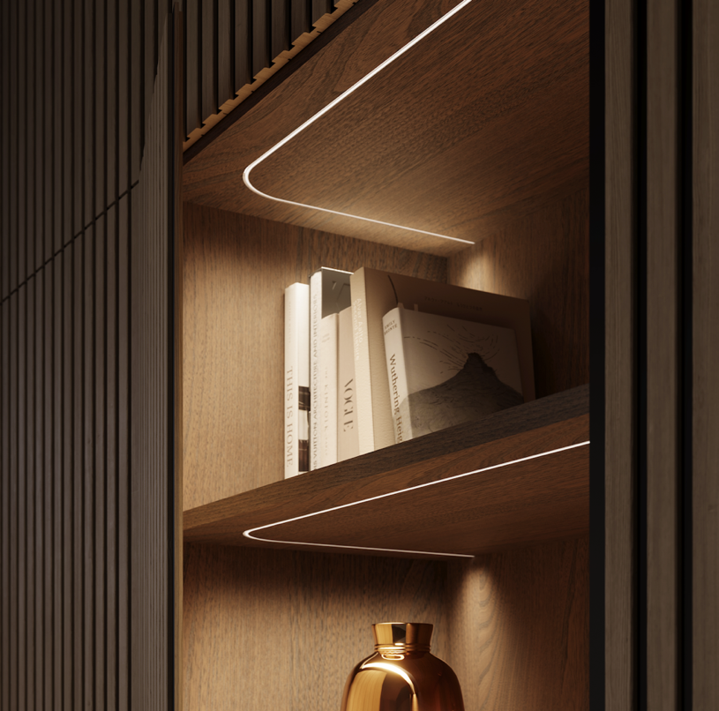
Richelieu’s FlexyLED SEH4 is ideal for customized lengths along curved surfaces

WAVE elements include the FlexyLED HE6B D-Motion Wave, a dimmable dual-white LED strip ideal for dynamic underlighting applications, and the HOLL D-Motion Wave, which delivers distinctive halo-patterned illumination perfect for under-cabinet installations. Additional versatile solutions such as the FlexyLED SEH4 and FlexyLED AT6 offer customizable cut lengths for precise integration beneath cabinetry and along curved surfaces. The lighting elements are compatible with the 96W Wireless Bluetooth BTRF LED Receiver, a fully wireless solution that offers convenient Bluetooth-enabled lighting control for added convenience and customization.

Event Details:
Closets Conference & Expo / Wood Pro Expo 2026
Palm Beach County Convention Center
650 Okeechobee Blvd
West Palm Beach, FL 33401
Tuesday, June 30: 8 am – 6 pm
Wednesday, July 1: 9 am – 5 pm
Visit Richelieu at Booth #405

About Richelieu
Richelieu is a leading North American importer, manufacturer, and distributor of specialty hardware and complementary products. An agent of change in a dynamic and creative industry, the company offers a broad mix of high-end, quality solutions for kitchens, bathrooms, closets, and cabinet storage. Richelieu’s products, sourced from worldwide manufacturers, serve a wide range of sectors including residential and commercial woodworking, furniture manufacturing, door, window, and hardware retailers, and renovation superstores.
###

