PRESS RELEASE
CONTACT:
Mary Beth Duehr: marybeth@duehrandassociates.com
Holly Berecz: holly@duehrandassociates.com
Duehr & Associates, LLC
1902 Wright Pl, Ste 200
Carlsbad, CA 92008
(760) 918-5622
Richelieu Showcases Innovative Solutions at 2026 International Woodworking Fair
From precision hardware and drawer technologies to customizable storage systems and high-quality surfacing, Richelieu’s new products helps the woodworking industry elevate interiors with craftsmanship, efficiency, and style
(Montreal, Canada, August 25, 2026) Richelieu Hardware will introduce its latest innovations for the woodworking industry at the upcoming International Woodworking Fair (IWF), taking place August 25 through 28, 2026 at the Georgia World Congress Center in Atlanta. With two booth experiences (#C1010 and #BC629), Richelieu unveils their extensive selection of functional and decorative hardware and accessories as well as their wood coating services and solutions, all designed to enhance craftsmanship, performance, and style.

North America’s oldest and largest wood products design and technology trade show and conference, IWF brings together professionals in the global woodworking sector to experience the newest wood-based and engineered materials. Visitors will find the latest solutions in surfacing, innovative hardware, architectural woodwork, cabinetry, furniture manufacturing, engineered products, doors, windows, machinery, tools, and more.

Richelieu’s newest introductions are designed to blend refined aesthetics with expanded capabilities, elevating every detail of modern interiors. These innovations allow woodworkers and manufacturers to create more cohesive, highly customized spaces with thoughtfully integrated details. The new products to be featured include:

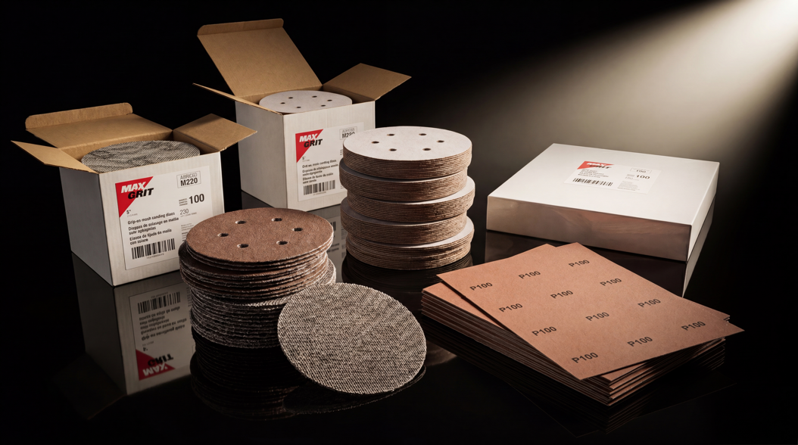
Richelieu introduces a new, exclusive collection of Max Grit™ abrasives

Every project begins with a surface, and how it’s prepared sets the stage for everything that follows. Richelieu introduces its new, exclusive Max Grit™ Abrasives collection, offering a versatile range of professional abrasives designed to deliver smooth, uniform sanding results across a variety of materials and working environments. The comprehensive collection includes a wide selection of grits in discs, belts, sheets, and sponges, providing dependable solutions for everyday surface preparation and finishing needs.

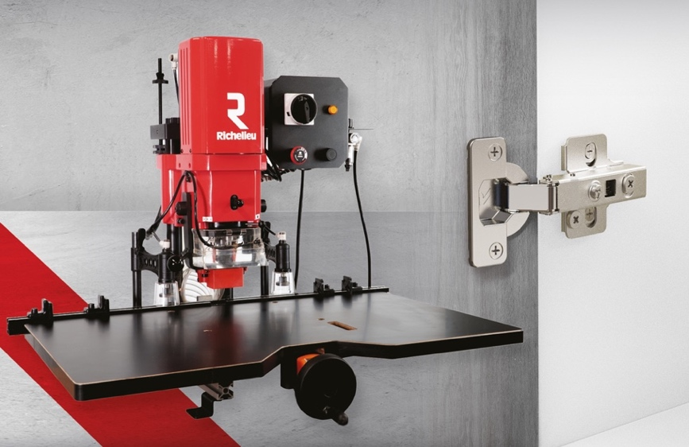
Richelieu Boring Machine

The Richelieu Boring Machine delivers fast, precise hinge cup boring for efficient cabinet production. Designed for quick setup and professional workshop performance, it is compatible with Richelieu RCS and RFF hinges.

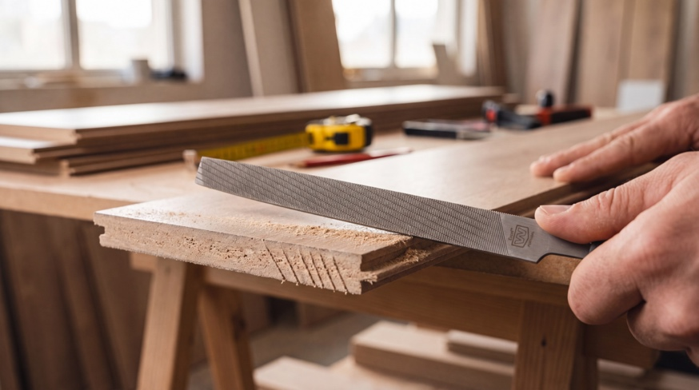
Richelieu Lamination Files

Professional laminate files designed for precise fabrication and efficient edge finishing. Available in Profile® for precision finishing, Excel® for fast stock removal, and Combination for versatile two-pattern cutting.

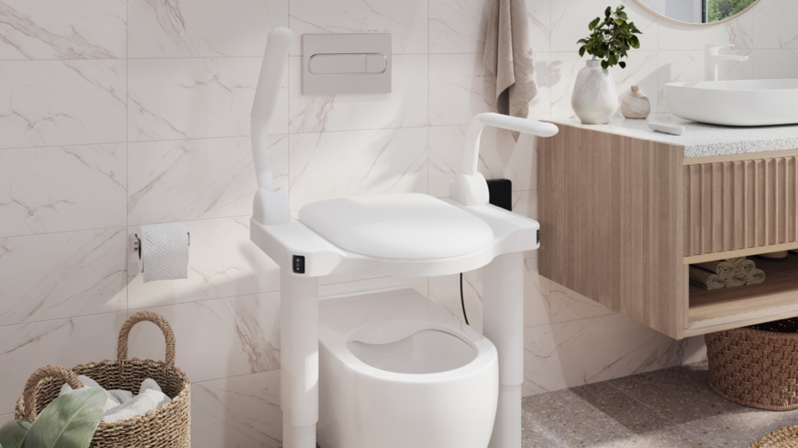
Richelieu’s UpRiser toilet seat lift

UpRiser is an innovative toilet seat lift designed to restore confidence, dignity, and independence to everyday bathroom routines. Combining safety, comfort, and Scandinavian-inspired simplicity, it allows users to operate the lift independently while its stable construction and ergonomic design provide reliable support. Refined, easy-to-clean surfaces make hygiene simple, and the streamlined design integrates seamlessly into modern bathrooms, providing discreet assistance without compromising aesthetics.

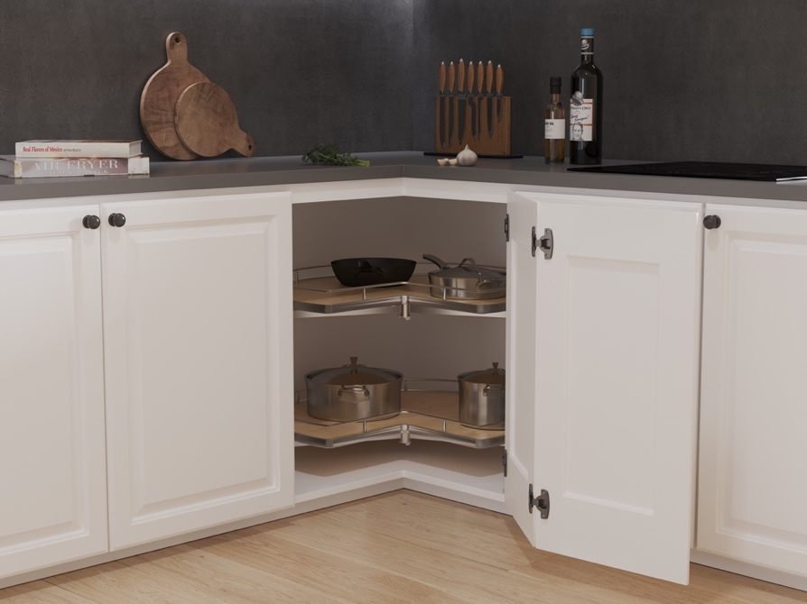
Richelieu offers a collection of storage solutions from Vauth-Sagel, including WheelPro
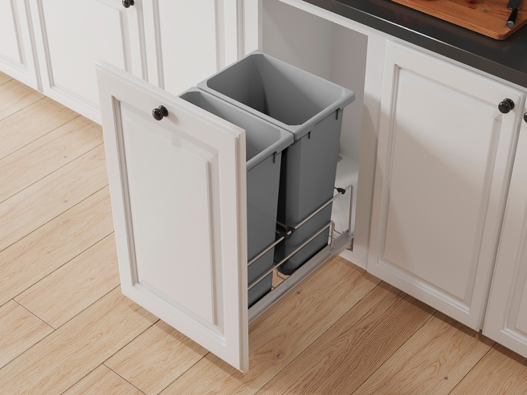
Vauth-Sagel’s ENVI bottom-mounted slide waste bin system from Richelieu

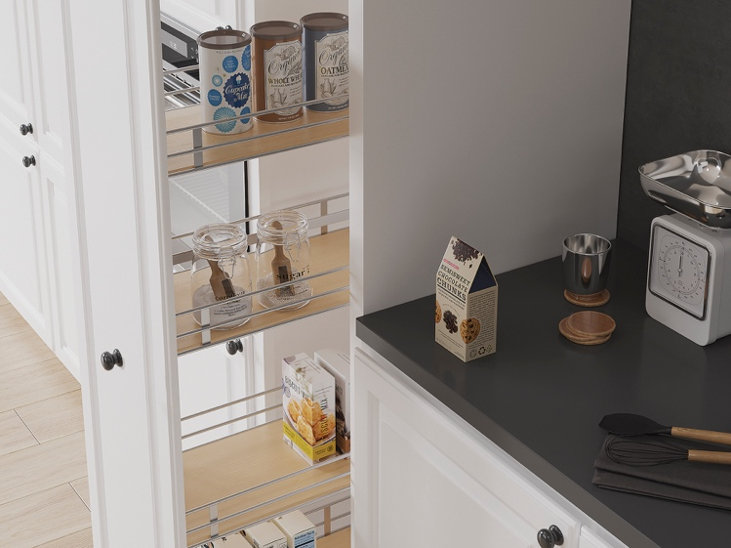
Vauth-Sagel’s VS TAL Pantry Pull-out from Richelieu

Thanks to a new partnership with Vauth-Sagel, Richelieu offers a range of smart storage solutions designed to improve comfort, organization, and efficiency in the kitchen. WheelPro maximizes hard-to-reach corner storage, creating up to 20-percent more space. ENVI provides stable, convenient waste management with integrated soft-close for quiet, smooth operation. Meanwhile, the VS TAL Pantry Pull-out optimizes vertical storage with easy, silent access to everyday essentials.

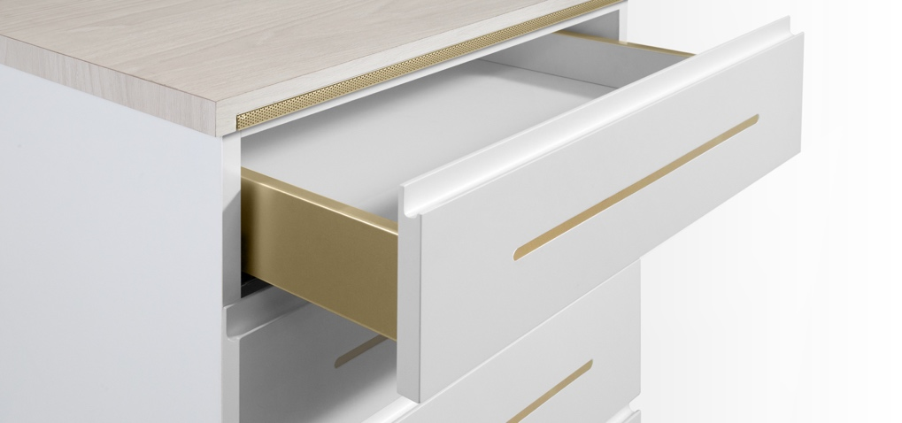
Richelieu’s flexible Windlight LED profile system

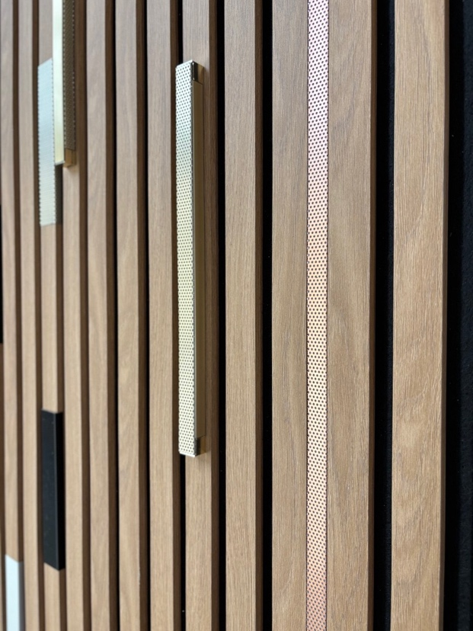
Richelieu’s Windlight on acoustic panel

Transform lighting into a sophisticated design element with Richelieu’s Windlight. Its minimalist aluminum profile, available with solid or micro-perforated covers, delivers precise illumination or a soft glow, while mix-and-match finishes allow for a customized look. The flexible system can be tailored to accent lighting, highlight architectural details, or create a warm, ambient atmosphere.

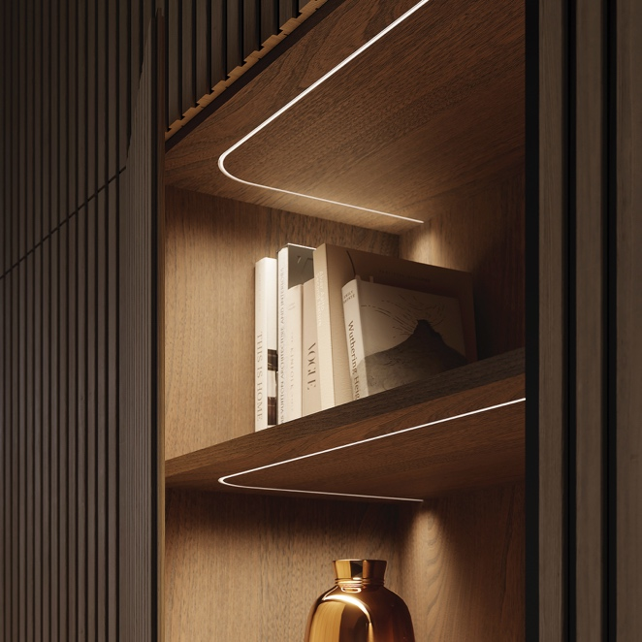

Richelieu’s FlexyLED SEH4 is ideal for customized lengths along curved surfaces

Part of the WAVE collection of lighting, FlexyLED SEH4 offers customizable cut lengths for precise lighting integration, especially along curved surfaces. Its compatible with the 96W Wireless Bluetooth BTRF LED Receiver, a fully wireless solution that offers convenient Bluetooth-enabled lighting control for added convenience and customization.

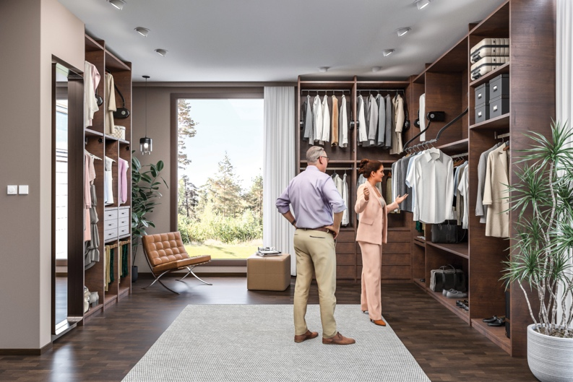
Richelieu’s Butler 732 pushbutton wardrobe lift

The Butler 730 and Butler 732 pushbutton wardrobe lifts transform the closet for enhanced accessibility. Raise and lower clothing with the push of a button, keeping your wardrobe organized and within easy reach. Ideal for seated users, the Butler 730 replaces a fixed clothes rail, bringing clothing down and forward for easy access. Meanwhile, the Butler 732 maximizes overhead closet space, allowing room for extra storage, an additional rail or shelving below.

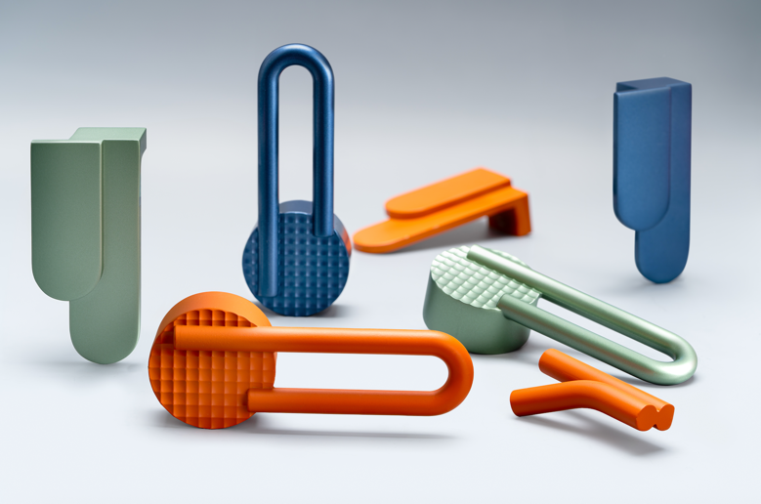
Richelieu’s Atipica hardware, designed by Gianmarco Codato and Luciano Trevisiol

Designed by Gianmarco Codato and Luciano Trevisiol, the Atipica designer hardware collection lets designers add character and identity to any project. Derived from the Italian word for “atypical,” Atipica is defined by eccentric geometric shapes and textures.

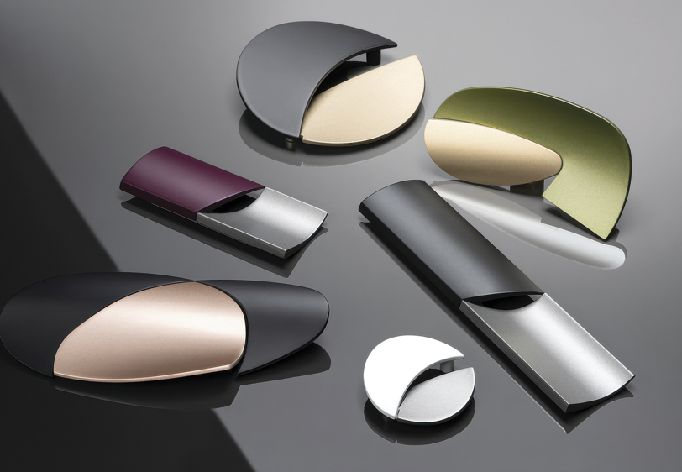
Richelieu’s geometric-inspired Alba hardware collection

The Alba Collection brings high-end Italian design to wardrobe cabinets and doors in this series of innovative geometric knobs and pulls. It pairs bold on-trend colors, such as plums and hot pinks, with understated greys and blacks that are punctuated by unexpected cut-outs and a dialogue between convex and concave volumes.

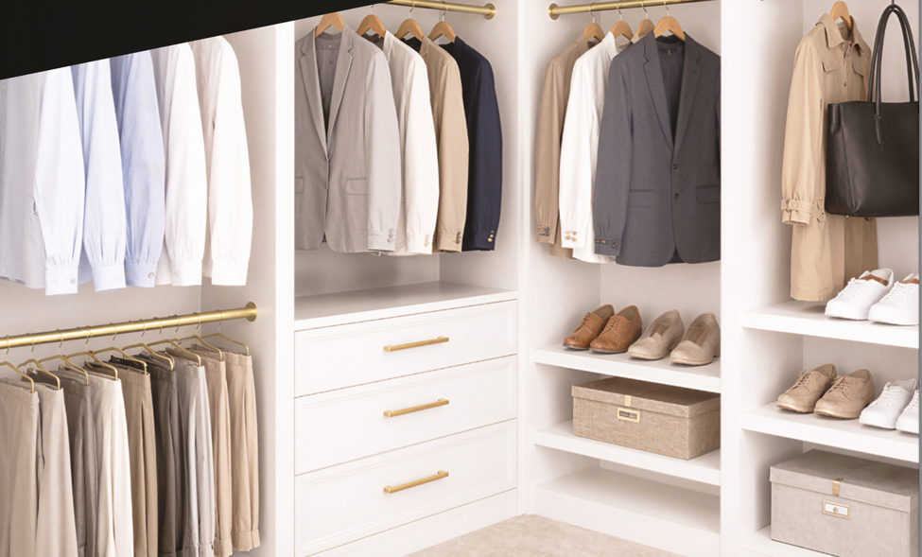
Richelieu’s Satin Brass Collection fully coordinated selection of accessories and finishing details

Richelieu’s Satin Brass Collection offers a cohesive design solution that unifies hardware, storage accessories, and lighting through a warm finish with a soft, sophisticated sheen. Extending seamlessly from pulls, knobs, hooks, shoe rails, belt and tie racks, and valet rods to closet rods, jewelry trays, drawer side panels, and integrated lighting, the collection creates visual continuity that guides the eye effortlessly from one element to the next.

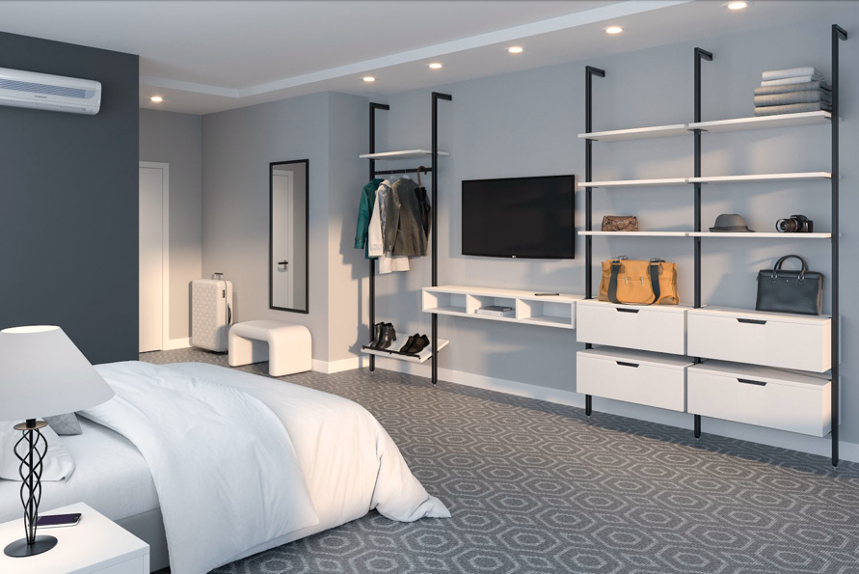
Richelieu’s flexible LOGO III closet system

The Logo III closet system offers flexible, modular storage solutions that can be customized for any project. Made of aluminum profiles that are perfect for wall and ceiling installation, this system can be cut to different dimensions to fit its intended space. Available in matte gray and matte black, the Logo III provides a modern aesthetic in a practical system of supports to keep clutter at bay and disorganization a thing of the past.

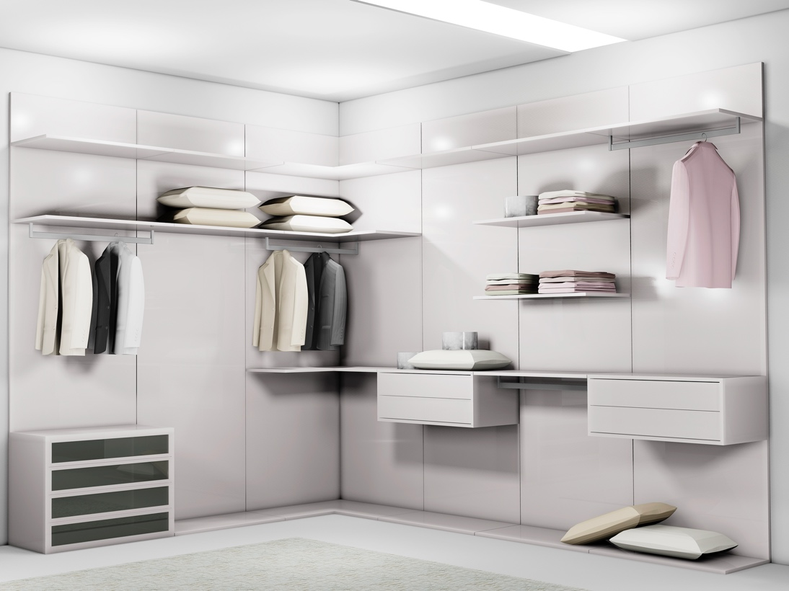
Richelieu’s fully customizable VERTIKO closet system

Richelieu’s VERTIKO closet system brings refined storage to life with a clean, modern aesthetic and fully customizable configurations. Its concealed aluminum profiles offer a minimalist look that adapts effortlessly as your needs change. Shelf and cabinet supports slide into narrow profile channels, allowing for quick and easy repositioning as needs change.

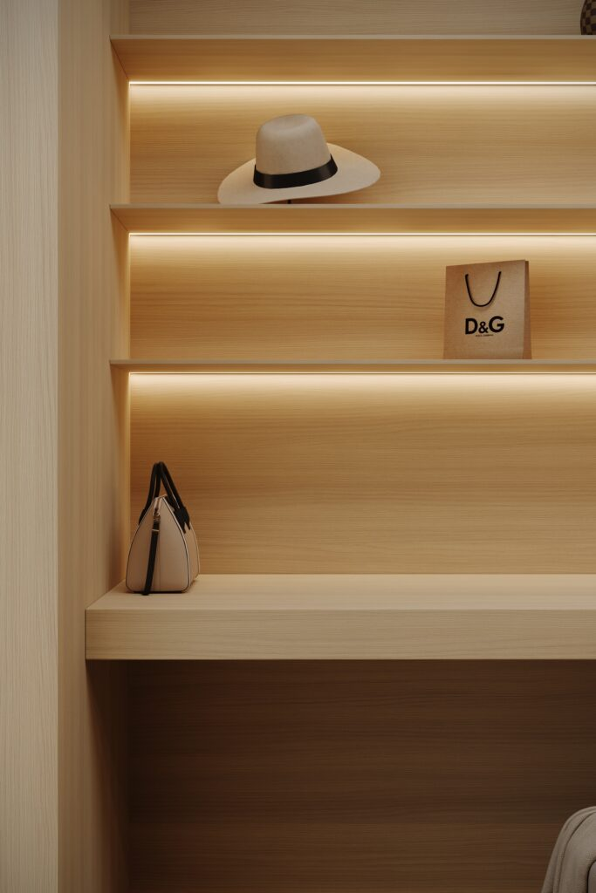
Richelieu’s Nature + Thermo-Structured Surface in Blondina

Nature + brings innovation and style together through an Italian designed Thermo-Structured Surface that delivers exceptional performance and visual appeal. Crafted in Italy, this highly durable, deeply textured surface is engineered to resist scratching and withstand sun exposure without fading, ensuring lasting beauty in any environment.

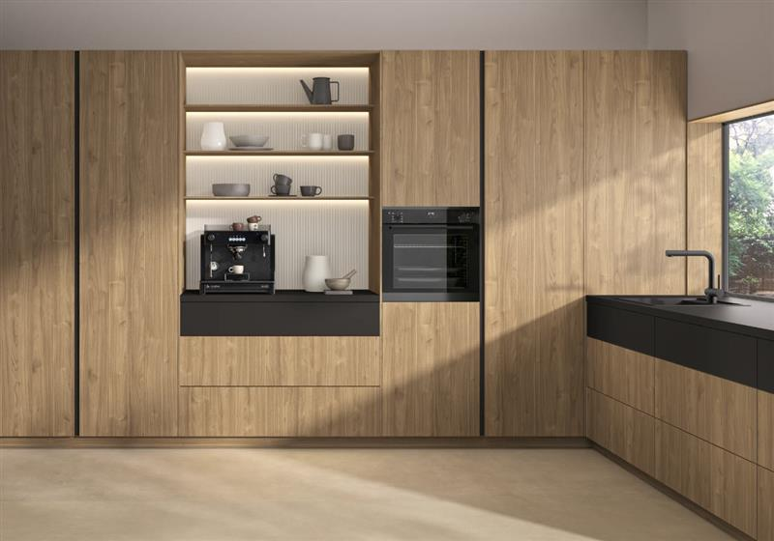
Richelieu’s Finsa Duo panels shown in Nogal Slow

Finsa Duo is a collection of thoughtfully designed, high-quality textured panels. With a selection of 39 contemporary colors, natural woodgrains and linen textures, it brings the perfect balance of beauty and versatility to closets, and beyond.

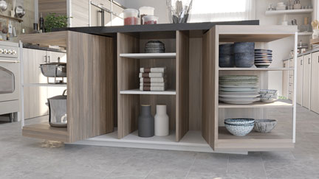
Richelieu’s ORBIX 360-degree rotating cabinet system

The revolutionary ORBIX rotating system allows entire elements to pivot 360-degrees, elegantly revealing or concealing interiors. With a single twist, spaces are transformed and fully accessible. Closed, ORBIX offers a sleek, refined façade. Open, it showcases contents with elegance and style. Elegant, innovative, and versatile, ORBIX redefines the cabinet experience, allowing a single piece of furniture to serve multiple purposes.

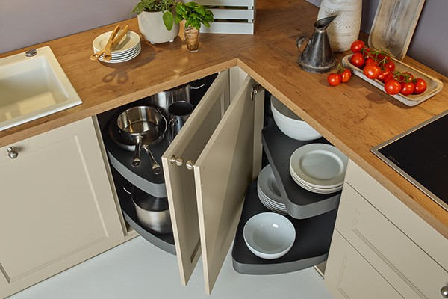
Richelieu’s TRIGON II corner system

The TRIGON II system maximizes corner cabinet storage with a smart two-tray design that makes awkward spaces more accessible. Designed for faceframe or frameless cabinetry, its 90-degree opening minimizes interference with adjacent cabinets and appliances. Adjustable, removable trays support up to 25 kg each, while an optional third tray provides additional storage for lighter items.

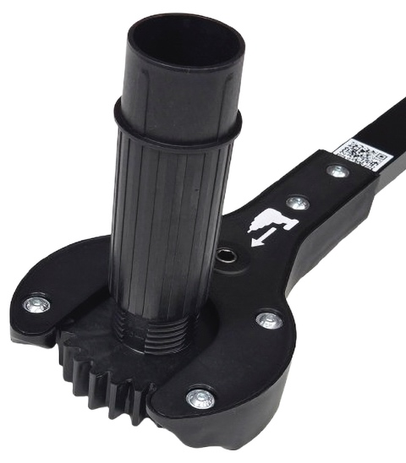
LVLR system from Richelieu

The Richelieu LVLR Leveler System delivers strength, stability, and precision for furniture and cabinet applications. Designed for quick, effortless adjustment with a drill, the system features wide 75 mm feet and supports up to 716 lbs. per leg. An extended-reach adjustment tool simplifies leveling in kitchens, closets, laundry rooms, garages, and more.

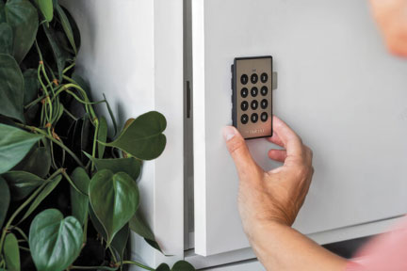
Richelieu’s Digital Keypad lock

Richelieu addresses the need for secure, keyless access with innovative new products. The Digital Keypad Lock features a scratch-resistant, soft-touch keypad, and easy management via the LEHMANN Smart Secure App. The Electronic Fingerprint Lock provides quick, secure entry with ultrafast scanning and a sleek design. These solutions deliver convenient, reliable and stylish security for modern spaces.

Event Details:
International Woodworking Fair
Georgia World Congress Center
285 Andrew Young International Blvd NW
Atlanta, GA 30313
Tuesday, August 25, 2026 through Friday, August 28, 2026, 8:30 am – 5:00 pm

Richelieu Product Solutions and Innovations: Booth C1010 (Building C, Level 1) Discover an extensive selection of functional and decorative hardware, accessories, and solutions designed for today’s industry professionals.

Richelieu Wood Coating Solutions: Booth BC629 (Hall BC, Level 1) Explore expert wood coating services and solutions designed to enhance craftsmanship and performance.

About Richelieu
Richelieu is a leading North American importer, manufacturer, and distributor of specialty hardware and complementary products. An agent of change in a dynamic and creative industry, the company offers a broad mix of high-end, quality solutions for kitchens, bathrooms, closets, and cabinet storage. Richelieu’s products, sourced from worldwide manufacturers, serve a wide range of sectors including residential and commercial woodworking, furniture manufacturing, door, window, and hardware retailers, and renovation superstores.
###

